Wellness Wednesday

Complete one of the following activities (or as many as you like!)

- Try the Take 5 Breathing Technique

- Try this guided Affirming and Accepting myself Visualisation

https://soundcloud.com/user-547419318/affirming-and-accepting-myself-visualisation-for-children-guided-by-ciara

- Complete a Wellness Diary ( see template attached) or create your own

- Create a Sensory bottle ( see instructions attached)
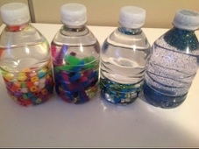

- Eat something healthy that you love today and notice how good it feels to nourish your body

- Take time to do something that makes you happy today- ride your bike, play with your favourite toy , sing a song
