Day | Monday 15th | Tuesday 16th | Wednesday 17th | Thursday 18th | Friday 19th
English | Reading: Read a book every day – DEAR time (Drop Everything And Read!) oxfordowl.co.uk have lots of different reading materials and a variety of books to read.  Writing:  Children will continue to write short sentences in their project copies. Please ensure writing is on the line and correct letter formation is used. We use finger spaces between words to make sure children space the words. A simple sentence and a picture is enough. Children can write a sentence about the weekend. E.g. Today is Monday. We can visit nana today!  Oral Language:  Discuss the calendar, what day is it today/yesterday/tomorrow, weather, month, season and year. | Reading: Revise any vocabulary and tricky words that you are finding hard/ read a library book  Handwriting  We have practiced to write all the letters. Well done you guys! You can revise letters in your copies if you are finding some letters difficult.  Oral Language:  Discuss the calendar, what day is it today/yesterday/tomorrow, weather, month, season and year.  Recall nursery rhymes.  After reading library book ask your child questions to show comprehension – sequence story – what happened next? | Read: Library Book/ oxfordowl.co.uk  Phonics: revise all sounds in sounds book and use Jolly Phonics small yellow book for blending. Try a set each day or as many as your child is able for.  We are now going to learn rhyming words. This week we will concentrate on ‘ug’ words e.g. bug, mug, rug, dug. Ask the children to think of words that sound like ‘ug’.  In their plain copies children can write these words.  Children should know all the alphabet sounds by sound and now by name.  Complete the page at the back of the big handwriting book, call out the letter name and your child should be able to write it correctly.  Oral Language:  Discuss the calendar, what day is it today/yesterday/tomorrow, weather, month, season and year. | Read: Library Book  Writing: summer holidays  Children can discuss their favourite summer activities and write three sentences about it in their project copy. What are they looking forward to this summer – maybe it’s the simple things like visiting friends now that the restrictions are lifting.  Oral Language:  Discuss the calendar, what day is it today/yesterday/tomorrow, weather, month, season and year. | Read: Library Book, revise all tricky words.  Writing: Today is Good News Friday! Tell a partner your Good News and record it in your project copy!  Oral Language:  Discuss the calendar, what day is it today/yesterday/tomorrow, weather, month, season and year.
Gaeilge | Folens online: Abair Liom A, resources, ag súil siar (revision)  Cinnín Óir agus na Trí Bhéar  Listen to the story and recall the story using Irish sentences. | Folens Online; Abair Liom A, resources, ag súil siar (revision)  An teach – thuas staighre  Amhrán - an Hócaí Pócaí  Foclóir 1 and 2 | Call out a colour and see if you can spot something with that colour  Dearg= red  Gorm= blue  Buí= yellow  Corcra= purple  Glas= green  Donn= brown  Dubh= black  Bán-dearg = pink  Play ‘Deir Ó Grádaigh’ (Simon Says)  Bí ag rith (running)  Bí ag damhsa (dancing)  Bí ag léim (jumping)  Bí ag imirt peile (football)  Bí ag péinteáil (painting)  Bí ag ithe (eating)  Bí ag ól (drinking)  Bí ag caoineadh (crying)  Bí ag gáire (laughing) | Folens Online; Abair Liom A, resources, ag súil siar (revision)  ag féachaint ar an scannán  listen to the comhrá and repeat sentences. | Call out a colour and see if you can spot something with that colour  Dearg= red  Gorm= blue  Buí= yellow  Corcra= purple  Glas= green  Donn= brown  Dubh= black  Bán-dearg = pink  Play ‘Deir Ó Grádaigh’ (Simon Says)  Bí ag rith (running)  Bí ag damhsa (dancing)  Bí ag léim (jumping)  Bí ag imirt peile (football)  Bí ag péinteáil (painting)  Bí ag ithe (eating)  Bí ag ól (drinking)  Bí ag caoineadh (crying)  Bí ag gáire (laughing)  .
Maths | This week children will be working on revision of all topics using your small home Busy at Maths book.  Choose any page that you think your child might need to revise. | This week children will be working on revision of all topics using your small home Busy at Maths book.  Choose any page that you think your child might need to revise. | This week children will be working on revision of all topics using your small home Busy at Maths book.  Choose any page that you think your child might need to revise. | This week children will be working on revision of all topics using your small home Busy at Maths book.  Choose any page that you think your child might need to revise. | This week children will be working on revision of all topics using your small home Busy at Maths book.  Choose any page that you think your child might need to revise.
P.E |  | Joe WICKS/Gonoodle/  Cosmic Yoga /daily walks |  | Joe WICKS/Gonoodle/  Cosmic Yoga /daily walks
SESE (Hist/Geog/Scien) |  |  | Talk to your child about something they enjoyed in school this past year. Ask your child to write three sentences and illustrate it.
Art |  | Show your child the famous painting ‘Sunflowers’ by Vincent Van Gogh. Ask your child to paint their own ‘Sunflowers’ painting.
Religion
Music | Music Generation  (see link on school website)

Links
Phonics sounds: YouTube
Jolly Phonics app

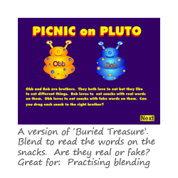Blending Game: https://www.phonicsplay.co.uk/PicnicOnPluto.html#

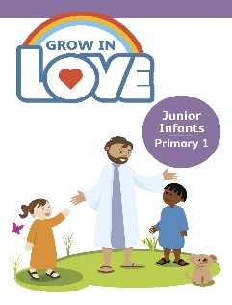Religion: Register an account with Grow in Love – use email trial@growinlove.ie
Password: growinlove

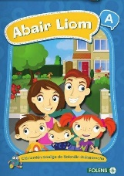 Gaeilge; Register an account with Folens Online - register as a teacher
Use Prim20 as the roll number
Abair Liom A
Resources

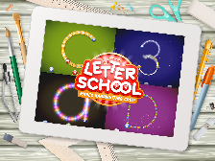 Handwriting: Letter school on YouTube

Reading: oxfordowl.co.uk

Jolly Phonics readers: https://www.jollylearning.co.uk/jolly-phonics-e-readers-now-available/
These are available on your android and apple devices.

Hello boys and girls,
Hope you boys and girls are keeping safe and well. We are nearly finished our weekly plans! Time is flying by!
Please remember to email me if you have not done so already!
My new email is mrstyrrellsclass@gmail.com
Our two favourite SNA’s have also new emails and these are ecocoman@gmail.com for Eilish and chrisleavy09@gmail.com for Chris.
We have another two birthday boys this week! Noah and Killian both will be six years old on Monday so a big Happy Birthday to you both! Hope you both have the best day and have lots of fun.
Keep up the good work boys and girls and remember we are nearly there! I am so proud of you all!
Keep safe everyone and look forward to hearing from you all,
Mrs. Tyrrell

