Day | Monday 1st | Tuesday 2nd | Wednesday 3rd | Thursday 4th | Friday 5th
English | BANK HOLIDAY WEEKEND | BANK HOLIDAY WEEKEND | Read: Library Book/ oxfordowl.co.uk  Phonics: revise all sounds in sounds book and use Jolly Phonics small yellow book for blending. Try a set each day or as many as your child is able for.  We are now going to learn rhyming words. This week we will concentrate on ‘et’ words e.g. net, bet, let, pet. Ask the children to think of words that sound like ‘et’.  In their plain copies children can write these words.  Revise the alphabet song – children now should learn the letter names (continue to use sounds for blending). Ask the children to show you a letter using letter name, not sound! Show me f, k, a etc. spell out family members names.  Oral Language:  Discuss the calendar, what day is it today/yesterday/tomorrow, weather, month, season and year.  After reading library book ask your child questions to show comprehension – sequence story – what happened next? | Read: Library Book  Writing: revise letter z practice writing it in the air or on each other’s back  Handwriting Book p.62  Oral Language:  Discuss the calendar, what day is it today/yesterday/tomorrow, weather, month, season and year.  Discuss the bank holiday weekend and what they did at the weekend. In project copy write two or three sentences in their copy about their weekend. Please remember finger spaces, proper letter formation (check writing book to make sure). | Read: Library Book, revise all tricky words.  Writing: Today is Good News Friday! Tell a partner your Good News and record it in your project copy!  Oral Language:  Discuss the calendar, what day is it today/yesterday/tomorrow, weather, month, season and year.  Handwriting Book p.63
Gaeilge |  |  | Call out a colour and see if you can spot something with that colour  Dearg= red  Gorm= blue  Buí= yellow  Corcra= purple  Glas= green  Donn= brown  Dubh= black  Bán-dearg = pink  Play ‘Deir Ó Grádaigh’ (Simon Says)  Bí ag rith (running)  Bí ag damhsa (dancing)  Bí ag léim (jumping)  Bí ag imirt peile (football)  Bí ag péinteáil (painting)  Bí ag ithe (eating)  Bí ag ól (drinking)  Bí ag caoineadh (crying)  Bí ag gáire (laughing) | Folens Online; Abair Liom A, resources, ag féachaint ar an scannán  Listen to the comhrá and try to repeat the sentences. | Folens Online; Abair Liom A, resources, ag féachaint ar an scannán  listen to the scéal and ask children to repeat sentences.  Play the game ‘tráth na gCeist’.
Maths |  |  | Revise playing shop with your child.  Today’s activity is based on the shop. This will be easier the more practice he/she has with playing shop. Let children buy two objects and combine them e.g. 2c and 1c make 3c.  Make sure children remember to say cent as in 2 cent and 1 cent make 3 cent.  Busy at Maths p.119 | Revise playing shop.  Busy at Maths p.120 | Revise the coins with your child, make a set with 1c coins, make a set with 2c coins and a set with 5c coins. Revise playing shop once again!
P.E |  |  |  | Joe WICKS/Gonoodle/  Cosmic Yoga /daily walks
SESE (Hist/Geog/Scien) |  |  | Children will learn all about Dr. Jane Goodall and her love for animals. This is all available on the folensonline.ie website. It is under the history section and the lesson is number 10, animals, history. Listen to the story, the q and a and the questions. |  | Explorers p.48  Children complete the page about Dr. Jane Goodall.
Art
Religion |  |  | Grow in Love p. 52  this week the children will learn about mass on Sunday, how the catholic church gather together to thank God for all that he has given us. We can still watch mass online at the moment. |  | Grow in Love p.53  Children illustrate what they are thankful for.
Music

Links
Phonics sounds: YouTube
Jolly Phonics app

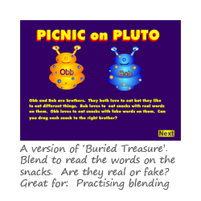Blending Game: https://www.phonicsplay.co.uk/PicnicOnPluto.html#

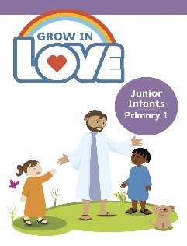Religion: Register an account with Grow in Love – use email trial@growinlove.ie
Password: growinlove

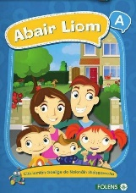 Gaeilge; Register an account with Folens Online - register as a teacher
Use Prim20 as the roll number
Abair Liom A
Resources

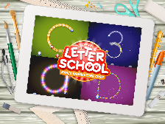 Handwriting: Letter school on YouTube

Reading: oxfordowl.co.uk

Jolly Phonics readers: https://www.jollylearning.co.uk/jolly-phonics-e-readers-now-available/
These are available on your android and apple devices.

Hello boys and girls,
How are you all keeping? I hope you had a fantastic long Bank Holiday weekend and made the most of the sunshine. Remember to keep safe and remember your sun cream in this weather!
A few parents have still not got to email me, please email me this week as I am eager to make contact with you all. Thank you so much for the lovely emails that I have received, it means a lot to me to get these emails and to hear that you are all keeping well.
My new email is mrstyrrellsclass@gmail.com
Our two favourite SNA’s have also new emails and these are ecocoman@gmail.com for Eilish and chrisleavy09@gmail.com for Chris.
We have three birthdays this month! We will celebrate Jayden, Noah and Killian’s birthdays in June.
I am sad that we will not get to enjoy this month together, June would have been a special one and we would have had lots of fun activities this month. This month would have been our school tour, our Teddy Bear’s picnic, our Sports Day and lots more. We can still do these activities but you can do them safely in your home. Yesterday we had the biggest Teddy Bear picnic in our garden, it was lots of fun.
Keep safe everyone and look forward to hearing from you all,
Mrs. Tyrrell

