[](https://www.google.ie/url?sa=i&url=https://printplaylearn.com/downloads/class-rule-prompts-rainbows/&psig=AOvVaw0rKW__DxGQx8uqEOjq6jKy&ust=1591823511369000&source=images&cd=vfe&ved=0CAIQjRxqFwoTCMiPgfTS9ekCFQAAAAAdAAAAABAe)[](https://www.google.ie/url?sa=i&url=https://www.wallquotes.com/vinyl-wall-quotes/inspirational/never-regret-being-kind-wall-quotes-decal&psig=AOvVaw22TddzcsvIn6AIkMgJBpEO&ust=1591823141349000&source=images&cd=vfe&ved=0CAIQjRxqFwoTCMC87MrR9ekCFQAAAAAdAAAAABAD)**Think of Others Thursday**

**Complete one of the following activities *(or as many as you like!)***

* **It is nice to be nice!**

**Choose three ‘Random Acts of Kindness’ from the board to complete this week.**

* **We know it is hard not seeing your school friends at the moment, but we will all be together again soon. I am trying to make a delicious recipe for a Friendship Pie! So far, I have 3 spoonfuls of kindness, a sprinkle of laughter and a pinch of patience! What other ingredients do you think would make a good Friendship Pie? (template attached).**

[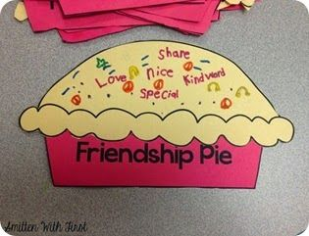](https://www.google.ie/url?sa=i&url=https://www.pinterest.com/pin/229542912233507282/&psig=AOvVaw1kFaZPsIg-QMybvDwNy4co&ust=1591828425569000&source=images&cd=vfe&ved=0CAIQjRxqFwoTCJiAtpHl9ekCFQAAAAAdAAAAABAD)

* **I bet there is someone that you really miss and can’t wait to give them a big squeeze! Why not fill out a ‘Keep This Hug Safe’ form, so they know that you are thinking about them (template attached).**
* **Try the Bumblebee Breathing Technique as you think about all the wonderful people in your life.**

[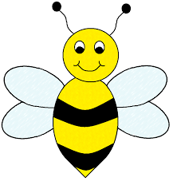](https://www.google.co.uk/url?sa=i&url=https://www.pinterest.com/pin/548454060848083440/&psig=AOvVaw3Raekbak6xbrGxzXa28opk&ust=1591828355983000&source=images&cd=vfe&ved=0CAIQjRxqFwoTCIDu-u_k9ekCFQAAAAAdAAAAABAE)