Thankful Tuesday
Choose one of the following activities (or as many as you like!) to remind us that there is always something to be grateful for.
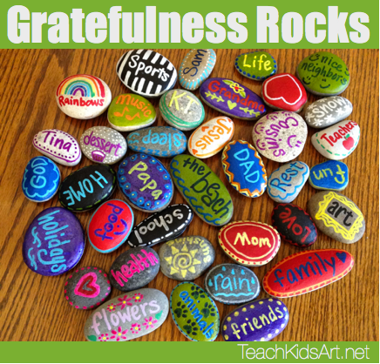
Don’t forget to send us photos!!!

Find a stone in your garden or on a walk. Wash it and write down something you are grateful for on it. Decorate it using markers, chalk, glitter etc.
Tip: write on paper and stick it to the stone.

Be Creative!!!

- Create a ‘Thank You Key Workers’ poster and display it proudly on your window. Perhaps, you would like to choose a template below to thank someone for keeping us safe.
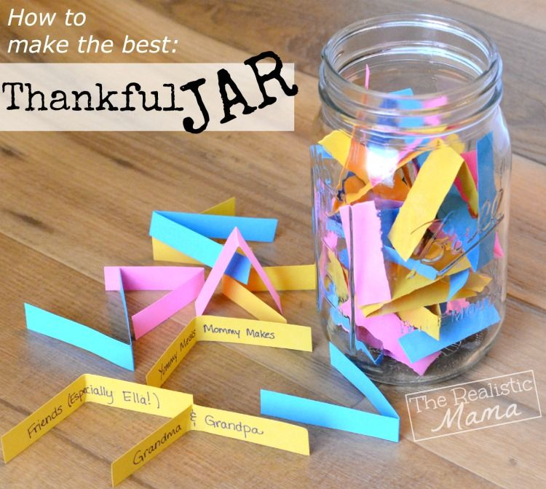
Every day write down something that you are grateful for and put it in to a Gratitude Jar e.g. smiles, family, pets, friends, music, food, sunshine.
Tip: Use a jam jar or a butter carton.
At the end of the week, read them before bed with your family and you will have lovely, happy dreams

- Try the Sun Breathing Technique as you reflect on all the things that you are thankful for in your life.

