GAA Skills

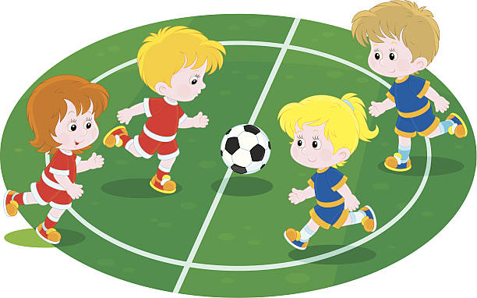
www.learninggaa.ie/haveaball
Football Skills
Kicking
- Hold the ball in your hands
- Swing your foot
- Drop the ball onto your foot and kick it.
- Keep your toes pointed straight in your shoes when kicking the ball.
Solo
- Hold the ball in your hands
- Put out foot
- Drop the ball onto your foot and it will bounce back up into your hands.
- To increase difficulty walk/run 3 steps between each solo.
Hand Pass
- Hold ball in one hand on an open hand.
- Make a fist with your other hand.
- Swing your fisted hand and hit the ball

