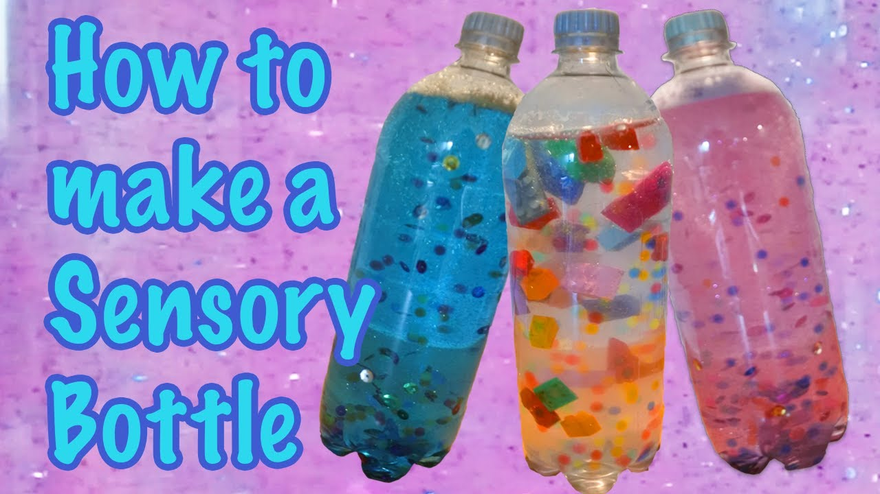
Sensory Bottles
Materials:
- 1 empty plastic bottle (younger children) empty jar (older children).
- Water
- Washin up liquid, or Cooking oil and food colouring, or
- Light corn syrup or clear shampoo or hair gel and small decorative items (such as sequins, buttons, or foil shapes)
Sensory bottles tend to have a very calming effect.
It is lovely to shake them and roll them and watch the contents swirl around.
- Choose whether you would like to make a bubble bottle, wave bottle, or slow-motion bottle.
- For a bubble bottle, fill the bottle 3/4 of the way with water. Add 2 tablespoons dish soap.
- For a wave bottle, fill the bottle 3/4 of the way with water. Add 2 tablespoons cooking oil and a few drops of food colouring.
- For a slow-motion bottle, fill the bottle with corn syrup, shampoo, or hair gel. Add the small decorative items of your choice.
- Be sure to seal the bottles so that they do not leak and small children do not have access to small parts that they can choke on.

