Day | Monday 15th June | Tuesday 16th June | Wednesday 17th June | Thursday 18th June | Friday 19th June
English | Reading; See page below  Spelling book p 66  Handwriting copy 1 page | Reading: As Monday and read book oxfordowls.co.uk  Blue ginn = age 5-6  Green ginn =age 6-7  Purple ginn = age 7-8  Other choose from  8-9 /9-10  Take out sound card and revise all sounds  Sounds make words  or  complete pages 69/70/71 | Reading Tricky word 1-72  Spelling book p 67 | Read poem  A giant’s tale  Read together /yourself  Are there any new words that you don’t understand  Colour them in and find out what they mean .  How is this story different from the one that we read in school ?  Complete wordsearch | Reminder: It is Good News Friday today –  Read: library book  sounds make words p 72/73/74
Gaeilge | Abair Liom B  Lesson 28  Listen to the story again and play vocabulary games 1 / 2  Activity book p.99  Spot the difference  Tá Daidí ag ithe ------  Tá Seán ag éisteacht le ceoil/ag togáil caisleáin gainimh  Tá Siofra ag -----  Tá culaith snámha ----- ar mamaí. Oráiste /glas | Folens Online; Abair Liom B, ceacht 28  Go over new vocab  Sing song /say poem  Activity book p 100  Listening activity is online  Eg dathaigh an éan gorm | Ceacht 28  Ar an trá  Listen to story again  Practise new vocab  Play vocab game 1 and 2  Listen to poem  Lá ar an trá | Folens Online; Abair Liom B,  Activity book p 101  Scamall,liathróid, buicáed ,bád ,caisleán,bó ,spád ,capall  Seán ag snámh san fharraige  Ag léamh leabhar  Ag éisteacht le ceol  Ag imirt cispheile  Ag togáil caisleán gainimh  Ag rith sa ghairdin
Maths | Count to 60 and count backways from 60 .children have difficulty crossing the zero number eg 32,31,30, 29  Make up some take away stories and write the number sentence in your copy  Eg There were 6 flowers in the garden .I picked 4 .How many were left ?  6 – 4 =2 | Count in 2’s to 30 and backways  Write some more take away sums within 10 in child’s maths copy  Use counters to complete sums | Count out 17 counters  Make numicon pattern of 10 with them ..  How many are left ? Make 7 pattern with them  17 = 10 + 7  Draw these patterns in maths copy  Write numeral 17  Write word seventeen | Repeat yesterdays activity with 18/19/20 | Small activity book 2 pages
P.E |  | Joe WICKS/Gonoodle/  Cosmic Yoga | imoves have some nice ideas and have free access at the moment | Joe WICKS/Gonoodle/  Cosmic Yoga
SESE (Hist/Geog/Scien) | Topic Animals  Science  Minibeasts online activities  Explore the interactive scene  Make a list of all the minibeasts you know  Label minibeasts in the picture | Remember the concept  Leave no trace  Go on a minibeast hunt in your garden/ park  Look in the grass /under logs /stones/in the flowers and trees  Complete table in your book | Look at video online about frogs and talk about it  Activity book p 51
Art |  |  |  | Listen to you tube read aloud  The Icky Sticky Frog | Google how to draw a frog and make your own picture of The Icky Sticky Frog  You could paint or colour it  Can you give him a long sticky tongue (sorry ! mum/Dad )
Religion
Music | Go to the Music Generation link at the bottom of the Covid 19 link on our website and check out the materials for Senior Infants

Links
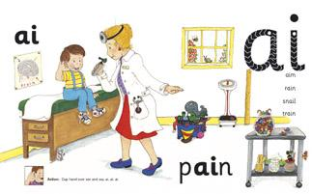Phonics ai sound : YouTube: https://www.youtube.com/watch?v=U2HYM9VXz9k&t=474

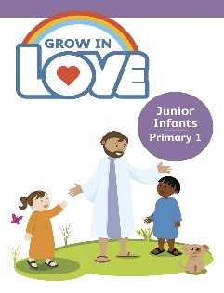Religion: Register an account with Grow in Love veritas
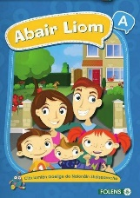 Gaeilge; Register an account with Folens Online Abair Liom Reading

- Revise wordlist Books 1-6
- Revise wordlist Book 7
- Tricky words 1-72
- If not on book 7 continue from where we stopped ,revising words covered and doing 1/2 rows of new vocabulary daily.
- As you become familiar with vocab start new reader.
- home.oxfordowl.co.uk have a great selection of free e-books and the children will recognise some of them .
- parents@harpercollins.co.uk password Parent 20 !
- jollylearning.co.uk have free access to jolly phonics readers

Hello boys and girls,
I hope you are all well and have had a good week. We are finished lots of our books and you have all worked very hard .Keep reading lots of books over the summer and you will be a fantastic first class. Don’t forget to listen out for magic WOW words when you are reading and ask an adult or your older brother/sister to explain them for you.

Have a good week and stay safe.
Mrs Gorman

