Day | Monday 11th | Tuesday 12th | Wednesday 13th | Thursday 14th | Friday 15th
English | Reading: continue to read ‘Where can GG Sit?’ – revise all vocabulary. Can you read sentences backwards? Mix up the words etc.  If finished reader read a book every day – DEAR time (Drop Everything And Read!)  Writing:  Children will be beginning to write short sentences in their project copies. Please ensure writing is on the line and correct letter formation is used. We use finger spaces between words to make sure children space the words. A simple sentence and a picture is enough. Children can write a sentence about the weekend. E.g. Today is Monday. We had a barbecue.  Oral Language:  Discuss the calendar, what day is it today/yesterday/tomorrow, weather, month, season and year. | Reading: Revise any vocabulary and tricky words that you are finding hard/ read a library book  Handwriting  In school we practice in rice or sand. If you have either, put a little into a tub/plate or bowl and let them trace the letter v.  Handwriting Book v p. 56  Oral Language:  Discuss the calendar, what day is it today/yesterday/tomorrow, weather, month, season and year.  Recall nursery rhymes. | Read: Library Book  Phonics: revise all sounds in sounds book and use Jolly Phonics small yellow book for blending. Try a set each day or as many as your child is able for.  We are now going to learn rhyming words. This week we will concentrate on ‘at’ words e.g. bat, cat, rat, sat, mat, fat, flat. Ask the children to think of words that sound like ‘at’.  In their plain copies children can write these words.  Introduce the alphabet song – children now should learn the letter names (continue to use sounds for blending). Ask the children to show you a letter using letter name, not sound! Show me f, k, a etc. spell out family members names.  Oral Language:  Discuss the calendar, what day is it today/yesterday/tomorrow, weather, month, season and year.  After reading library book ask your child questions to show comprehension – sequence story – what happened next? | Read: Library Book  Writing : revise letter v practice writing it in the air or on each other’s back  Handwriting Book p.57  Oral Language:  Discuss the calendar, what day is it today/yesterday/tomorrow, weather, month, season and year.  Discuss ‘the supermarket’ and what they know about the supermarket. In project copy draw the supermarket and write two sentences about it e.g. the supermarket is big. We buy food there.  Please remember finger spaces, proper letter formation (check writing book to make sure). | Read: Library Book, revise all tricky words.  Writing : Today is Good News Friday! Tell a partner your Good News and record it in your project copy!  Oral Language:  Discuss the calendar, what day is it today/yesterday/tomorrow, weather, month, season and year.  Handwriting Book (small) p.23
Gaeilge | Folens online: Abair Liom A, resources, Súil Siar 4  Tráth na gceist  Click on the correct picture. | Folens Online; Abair Liom A, resources, Súil Siar 4  In the child’s plain day copy ask them to listen and draw (éist and tarraing)  Tá Seán ag caoineadh – Sean is crying.  Tá Daidí ag féachaint ar an téilifís – Daddy is watching television.  Tá Síofra ina luí – Síofra is lying down.  Tá mamaí ar an tolg – Mammy is on the couch. | Call out a colour and see if you can spot something with that colour  Dearg= red  Gorm= blue  Buí= yellow  Corcra= purple  Glas= green  Donn= brown  Dubh= black  Bán-dearg = pink  Play ‘Deir Ó Grádaigh’ (Simon Says)  Bí ag rith (running)  Bí ag damhsa (dancing)  Bí ag léim (jumping)  Bí ag imirt peile (football)  Bí ag péinteáil (painting)  Bí ag ithe (eating)  Bí ag ól (drinking)  Bí ag caoineadh (crying)  Bí ag gáire (laughing) | Folens Online; Abair Liom A, resources, Súil Siar 4  Tráth na gceist  Click on the correct picture. | Listen to the scéal ‘Cinnín Óir’ again. In school the children always enjoyed these online stories so I hope they are enjoying them at home too! Encourage them to join in with the story, they always did at school!
Maths | Children will be working on number and addition. We have already covered addition but this time the objects are vertical. We will practice lots using concrete materials – cubes.  You model the sums in the book and ask child them orally on p.108 (do not complete the page today). | Children will continue working on number and addition. We have already covered addition but this time the objects are vertical. We will practice lots using concrete materials – cubes.  You model the sums in the book and ask child them orally.  Now ask your child to complete  Busy at Maths p.108 | Children will continue working on number and addition. We have already covered addition but this time the objects are vertical. We will practice lots using concrete materials – cubes.  You model the sums in the book and ask child them orally (do not complete the page today). | Children will continue working on number and addition. We have already covered addition but this time the objects are vertical. We will practice lots using concrete materials – cubes.  You model the sums in the book and ask child them orally.  Now ask your child to complete  Busy at Maths p.109 | https://www.topmarks.co.uk/maths-games/3-5-years/counting
P.E |  | Joe WICKS/Gonoodle/  Cosmic Yoga /daily walks |  | Joe WICKS/Gonoodle/  Cosmic Yoga /daily walks
SESE (Hist/Geog/Scien) | Explorers p.44  Discuss materials and different materials that we have in our homes – plastic, metal, wood, fabric.  Complete page. |  | Explorers p.45  Discuss materials and different materials that we have outside – plastic, metal, wood, stone.  Complete page. |  | Discuss summer and characteristics of summer. If possible go for a nature walk and look for signs of summer, or look for signs of summer in your garden.
Art |  | Talk to the children about summer and what happens in summer. Discuss the insects that we see in summer e.g. bee. Ask children to draw or paint a bee.
Religion |  | Talk to your child about their baptism. |  |  | Grow in Love p. 49
Music | Music Generation  (see link on school website)

Links
Phonics sounds : YouTube
Jolly Phonics app

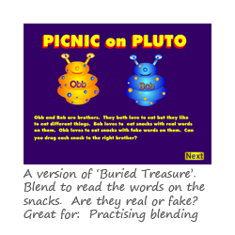Blending Game: https://www.phonicsplay.co.uk/PicnicOnPluto.html#

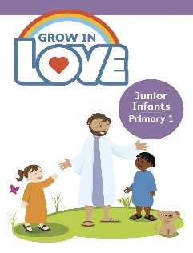Religion: Register an account with Grow in Love – use email trial@growinlove.ie
Password: growinlove

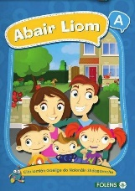 Gaeilge; Register an account with Folens Online - register as a teacher
Use Prim20 as the roll number
Abair Liom A
Resources

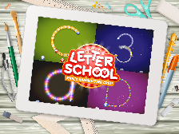 Handwriting: Letter school on YouTube

Hello boys and girls,
I hope you and your family are keeping safe and well. I hope you are all working hard and getting loads of work done and also helping mammy and daddy. We have been so lucky with this weather and I hope it continues so we can discuss summer later on this week.
Remember you can post your Good News Friday on our twitter page and I can read them that way, I would love to hear yours as I am missing you all loads.
Keep safe everyone,
Mrs. Tyrrell

