Day | Monday 4th | Tuesday 5th | Wednesday 6th | Thursday 7th | Friday 8th
English | Happy Bank Holiday!! | Reading: Revise any vocabulary and tricky words that you are finding hard/ read a library book  Handwriting j  In school we practice in rice or sand. If you have either, put a little into a tub/plate or bowl and let them trace the letter j.  Handwriting Book j p. 54  Oral Language:  Discuss the calendar, what day is it today/yesterday/tomorrow, weather, month, season and year.  Recall nursery rhymes. | Read: Library Book  Phonics: revise all sounds in sounds book and use Jolly Phonics small yellow book for blending. Try a set each day or as many as your child is able for.  In their plain copies children can write these words (sound them out for your child)- cat, dog, bat, log, man, cup, top.  Introduce the alphabet song – children now should learn the letter names (continue to use sounds for blending). Ask the children to show you a letter using letter name, not sound! Show me f, k, a etc. spell out family members names.  Oral Language:  Discuss the calendar, what day is it today/yesterday/tomorrow, weather, month, season and year.  After reading library book ask your child questions to show comprehension – sequence story – what happened next? | Read: Library Book  Writing : revise letter j practice writing it in the air or on each other’s back  Handwriting Book p.55  Oral Language:  Discuss the calendar, what day is it today/yesterday/tomorrow, weather, month, season and year.  Discuss summer and what they like about summer. In project copy draw their favourite thing about summer and write two sentences about summer e.g. It is hot in summer. My birthday is in summer. We wear shorts in summer.  Please remember finger spaces, proper letter formation (check writing book to make sure). | Read: Library Book, revise all tricky words.  Writing : Today is Good News Friday! Tell a partner your Good News and record it in your project copy!  Oral Language:  Discuss the calendar, what day is it today/yesterday/tomorrow, weather, month, season and year.  Handwriting Book (small) p.22
Gaeilge |  | Folens Online; Abair Liom A, resources, Cinnín Óir agus na Trí Bhéar  Click on the luaschartaí section and this will provide the new vocab.  Cinnín Óir – Goldilocks  Na trí Bhéar – the three bears  An coill – the forest  Babhla – bowl  Leite – porridge  Cathaoir – chair  Leaba – bed  Ina c(h)odladh - asleep  Click on scéal to listen to the story. | Call out a colour and see if you can spot something with that colour  Dearg= red  Gorm= blue  Buí= yellow  Corcra= purple  Glas= green  Donn= brown  Dubh= black  Bán-dearg = pink  Play ‘Deir Ó Grádaigh’ (Simon Says)  Bí ag rith (running)  Bí ag damhsa (dancing)  Bí ag léim (jumping)  Bí ag imirt peile (football)  Bí ag péinteáil (painting)  Bí ag ithe (eating)  Bí ag ól (drinking)  Bí ag caoineadh (crying)  Bí ag gáire (laughing) | Folens Online; Abair Liom A, resources, Cinnín Óir agus na Trí Bhéar  Revise the luaschartaí.  Listen to the story(scéal) and see if the children can tell you a little about it. | Listen to the scéal again. In school the children always enjoyed these online stories so I hope they are enjoying them at home too! Encourage them to join in with the story, they always did at school!
Maths |  | Children will be discussing the days of the week. Say the days of the week with your child and ask them what day is today/yesterday/tomorrow? What day comes after Friday/Monday?  Make flashcards with the days of the week and help children read them and decorate them! We start with Monday! | Revise all days of the week. What day comes after Tuesday/Thursday etc.  What is your favourite day? Why?  Mix up the cards and ask your child to put them back in order. | Revise all the days of the week. Revise all questions and mix up the flashcards again. Play a game that you say a day and can child remember what day comes next.  Busy at Maths p.106 | Revise all the days of the week. Revise all questions and mix up the flashcards again. Play a game that you say a day and can child remember what day comes next.  Busy at Maths p.107
P.E |  | Joe WICKS/Gonoodle/  Cosmic Yoga /daily walks |  | Joe WICKS/Gonoodle/  Cosmic Yoga /daily walks
SESE (Hist/Geog/Scien) |  |  | Explorers p.42  Discuss how grown up your child is now! What can they do now that they could not do as a baby, what has changed? Talk about how what they wear has changed – what did they wear as a baby? Do they still wear a bib, nappy, Babygro? Why not? Complete p.42. |  | Explorers p.43  Talk about what clothes we wear for the different seasons – winter and summer. Why do we wear coats/hats/scarf in winter? It is cold!  Why do we wear shorts/dresses/sun hats in summer? It is hot!  Complete the page. In school we would have templates to cut out but children can just draw on the clothes!
Art |  | Talk to the children about summer and what happens in summer. Discuss the flowers, the sunshine, the clothes we wear, barbecues, playing outside, longer days. Children can draw/paint a summer picture.
Religion |  | talk to your child about water and how important water is. talk about all the ways we use water. Emphasise that we are very lucky to have clean water in our homes. | Grow in Love p. 46 |  | Grow in Love p. 47
Music

Links
Phonics sounds : YouTube
Jolly Phonics app

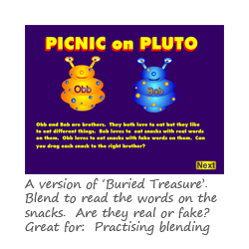Blending Game: https://www.phonicsplay.co.uk/PicnicOnPluto.html#

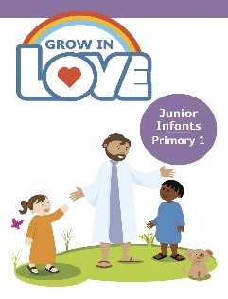Religion: Register an account with Grow in Love – use email trial@growinlove.ie
Password: growinlove

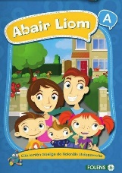 Gaeilge; Register an account with Folens Online - register as a teacher
Use Prim20 as the roll number
Abair Liom A
Resources

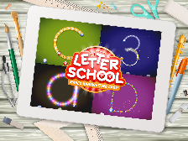 Handwriting: Letter school on YouTube

Hello boys and girls,
Summer is here! I hope you enjoy a nice bank holiday weekend with your family at home where you can be safe and well. I am sure some of you are finding it hard to do this work at home, remember my Jack is in the same class as you and we have days that are difficult! Please remember that mammy and daddy might find this hard too so always be kind! Take a little break when you need one but I always want you to try your best, show mammy and daddy how you are the best Junior Infants in Ireland!!
I know that this week would have been a special one for Kai, Ciara and Megan as their siblings would have been celebrating their Confirmation – perhaps do something special as a family on Thursday to cheer everyone up.
Remember you can post your Good News Friday on our twitter page and I can read them that way, I would love to hear yours as I am missing you all loads.
Keep safe everyone,
Mrs. Tyrrell

