Feel Good Friday
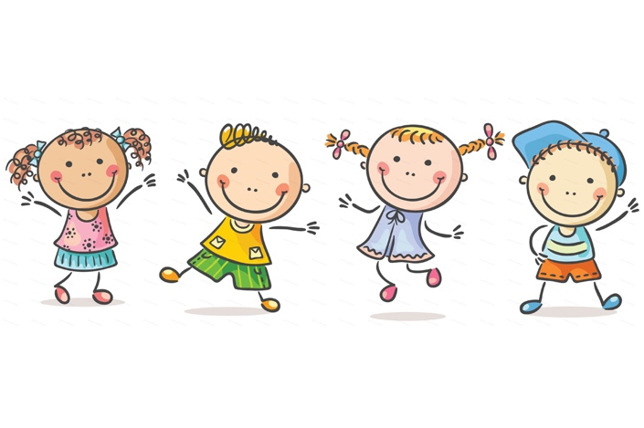
Complete one of the following activities (or as many as you like!)

- Try the Ocean Breathing Activity ( attached)

- Try the best Version of Myself Visualisation

https://soundcloud.com/user-547419318/the-best-version-of-myself-guided-visualisation-for-children-led-by-colm

- What makes you happy? Complete the Bucket of happiness activity ( template attached or create your own)

- Spread the love- Do three things to bring joy to other people today e.g help your mam, play with your brother or sister, phone your granny

- Tea and Talk- Sit down and have a chat with someone at home while enjoying your favourite drink

