Today’s Activities

Pick one - or more if you like !

1. Your favourite activity

2. An activity that you did not get around to trying

3. An activity that you would like more practice in

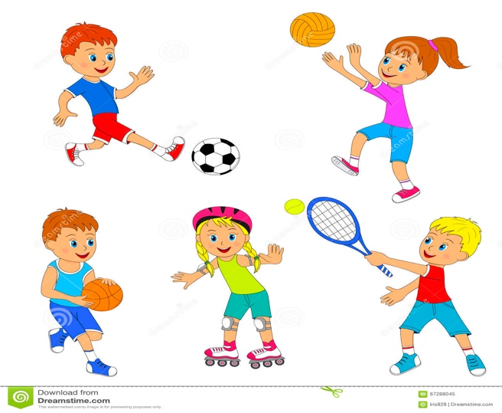

Have Fun & Remember

Together We Can Do Great Things

