Today’s Activities

Pick one - or more if you like !

- Playground games

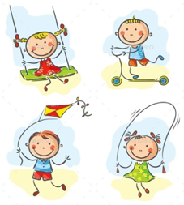

- GAA Skills

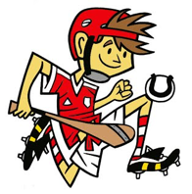

3. Fitness Stations

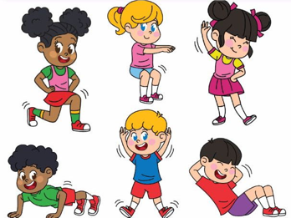

Have Fun & Remember

Together We Can Do Great Things

