Today’s Activities

Pick one - or more if you like !

- Traditional Sports Day Races

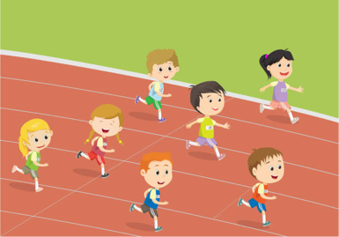

- Joe Wicks workout

3. Body Movement Activity

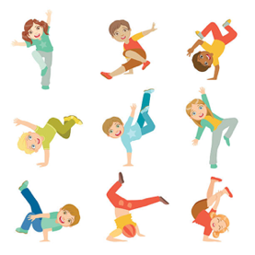

Have Fun & Remember

Together We Can Do Great Things

