Today’s Activities

Pick one - or more if you like !

- Scavenger Hunt

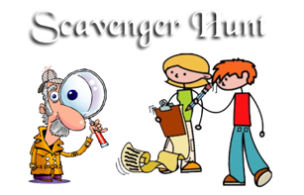

- Obstacle Course

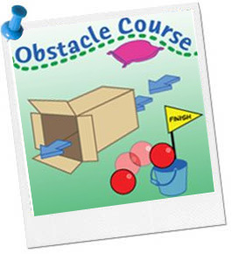

3. Outdoor Activity

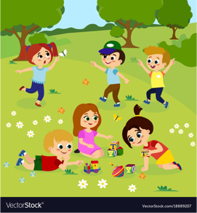

Have Fun & Remember

Together We Can Do Great Things

