Today’s Activities

Pick one - or more if you like !

1. Yoga - yoga session with cosmic kids

https://www.cosmickids.com

2. Yoga Moves - practice some yoga moves by following picture instruction cards

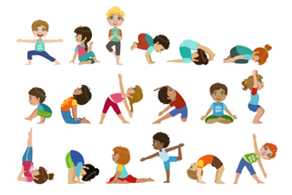

3. Dance - get moving with the help of GoNoodle

https://www.gonoodle.com/good-energy-at-home-kids-games-and-videos/

Have Fun & Remember

Together We Can Do Great Things

