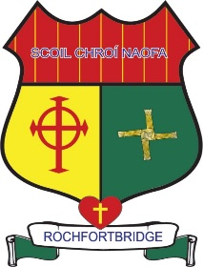

Scoil Chroí Naofa
Rochfortbridge, Co. Westmeath
e-mail: scoilchroinaofarb@gmail.com
Phone: (044)9222389

Below please find a list of Covid-19 email contacts for us all in Scoil Chroí Naofa. As always you may also contact us at scoilchroinaofarb@gmail.com

Ms. Grace Tyrrell Junior Infants mrstyrrellsclass@gmail.com
Ms. Chris Leavy chrisleavy09@gmail.com
Ms. Eilish Cocoman ecocoman@gmail.com

Ms. Ger Gorman Senior Infants mrsgormanseniorinfants@gmail.com

Ms. Michelle Dardis 1st Class msmdardis1stclass@gmail.com

Ms. Therese Comerford 2nd Class MTComerfordscn@gmail.com

Ms. Paula Kilmurray 3rd Class mskilmurraysclass@gmail.com

Mr. Enda Claffey 4th Class mrclaffeyscnrb@gmail.com

Mr. Michael Cleary 5th Class A mrclearysclass1@gmail.com

Ms. Trish Greene 5th Class B pgreenescnrb@gmail.com

Ms. Mary Seery 6th Class mrsseery6th@gmail.com

Ms. Deirdre Molloy SET mrsmolloy9@gmail.com

Ms. Margaret Culkin SET mculkinscnrb@gmail.com

Ms. Ulrika Maher SET msmaherscnrb@gmail.com

Ms. Lisa Colleary SET mrscolleary@gmail.com

