Scoil Chroí Naofa gets Physical!!

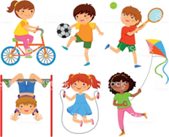

Active School Week 2020

Have Fun & Remember

Together We Can Do Great Things

In Scoil Chroí Naofa we love all sports and activity. We love football, hurling, soccer, basketball, athletics, swimming, dancing and much much more.
This week we would love you to get active and get out and exercise. Each day we will be sending you different ideas to try out. We will also be sending some helpful resources to get you started but of course you can use your imagination too!
Try to do 1 or 2 activities a day.
Send us a picture - We would love to see you!

Have Fun & Remember

Together We Can Do Great Things

