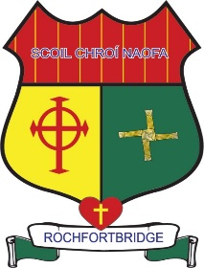

Scoil Chroí Naofa
Rochfortbridge, Co. Westmeath
e-mail: scoilchroinaofarb@gmail.com
Phone: (044)9222389

Class Allocation 2020/2021

Ms. Grace Tyrrell Junior Infants
Ms. Ger Gorman Senior Infants

Ms. Michelle Dardis 1st Class

Ms. Therese Comerford 2nd Class

Ms. Paula Kilmurray 3rd Class

Mr. Enda Claffey 4th Class

Ms. Trish Greene 5th Class

Mr. Michael Cleary 6th Class A (same class as last year)

Ms. Mary Seery 6th Class B

Ms. Deirdre Molloy SET

Ms. Margaret Culkin SET

Ms. Ulrika Maher SET

Ms. Lisa Colleary SET

