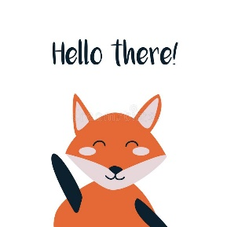
Good morning Second Class
Abi , Tom, Anna, Anya, Leah, Ruby, Ryan K, Ryan P, Bayya, Elise, Emily, Grace, Harry, James, Cathal, Eimear, Eoghan, Kallum, Liadán, Sophia, Thomas C, Thomas M, Ava Lily, Daibhín, Darragh, Emma May, Orlaith, Pauraic, Shaynah, Stephen, Ava Helen, Kayleigh,

I hope you are all well.
. My email address is MTComerfordscn@gmail.com
You can send me an email if you have any questions about your school work. You can also send me a picture of your work, your activities at home, etc….anything that you have achieved that makes you feel really proud.
I hope you all had a lovely weekend.
It’s the middle of June and we’re nearly finished. Yessssssss! So stay calm, finish off those last few pages and that’s it. I am sure you lots of other very important things to do.

Second Class: This is your suggested plan of work for this week.
Just try your best – there is no need to worry about not understanding a topic or not finishing any activity.

It is very important that
- Wash your hands
- Get some fresh air everyday (within 20 kilometres from your home or in your own county!!)
- Relax.
- Check out some videos from National Geographic for Kids – Weird but true fast facts
https://www.youtube.com/watch?v=nuJ75_PhnGA&feature=emb_logo
https://www.youtube.com/watch?time_continue=31&v=-g6XPe4J5rs&feature=emb_logo

Second Class Week 9– Summer Term
Day | Monday June 15th | Tuesday June 16th | Wednesday June 17th | Thursday June 18th | Friday June 19th
English
 | Reading/Novel  My Read at Home Book 2 – second class (C J Fallon)  (Read 1 story per day and see if you can answer the questions – orally.) | Reading/Novel  My Read at Home Book 2 – second class (C J Fallon)  (Read 1 story per day and see if you can answer the questions – orally.) | Reading/Novel  My Read at Home Book 2 – second class (C J Fallon)  (Read 1 story per day and see if you can answer the questions – orally.) | Class Novel  Don’t forget Fantastic Mr Fox, or your own choice. | Reading - DEAR  (Drop Everything And Read)
Have you logged onto Epic books? How many books have you read?
Your parents should have received an email from Epic. If they haven’t, let me know.
 | Spelling  Make your own list of 20 summer words for example – swimming.  Ask an adult to help you check the spelling. Or you may use a dictionary…or Google.  Learn how to spell them. | Spelling  Same as Monday | Spelling  Same as Monday | Spelling  Same as Monday | Test yourself
Handwriting
- Page 63
 | 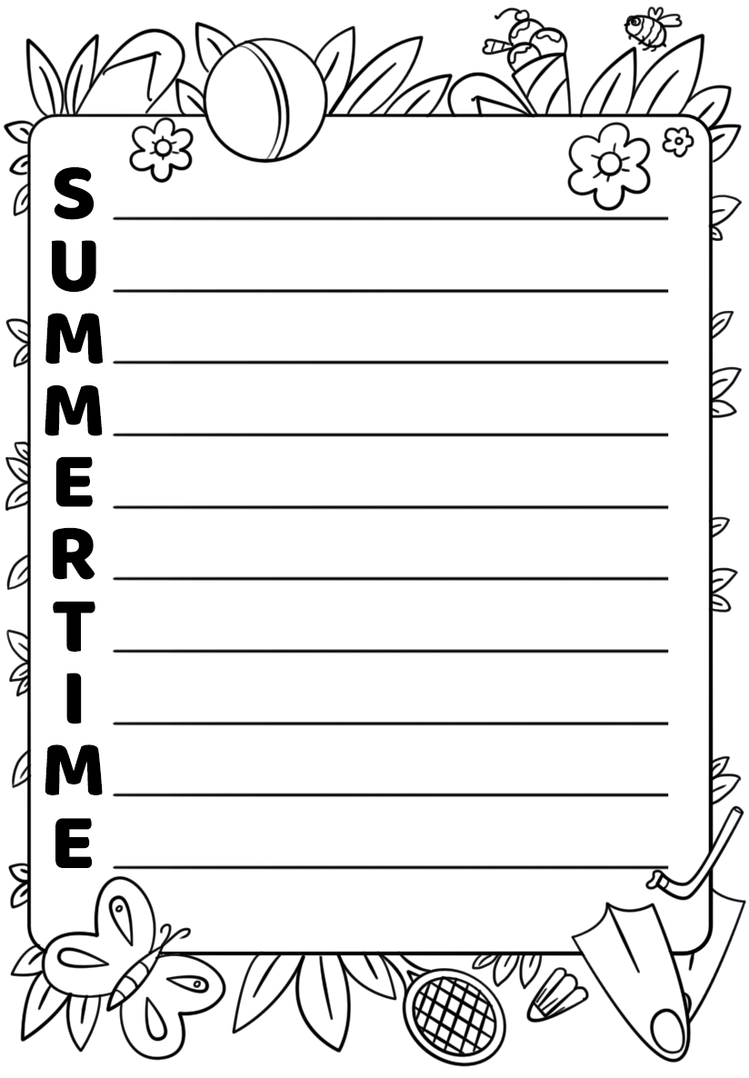 | Writing  Write an acrostic about summertime.  Write the letters of SUMMERTIME down the side of the page. Write a sentence starting with each letter. For example  Sandals on my tanned feet  Under the tree, I sit in the shade | Writing  Check your writing from yesterday. | Writing  Illustrate
Gaeilge | Abair Liom D Unit 30 –Le foghlaim 2 142.  Look at the example.  Make your own sentences.  Write 5 of them at the bottom of the page. | Abair Liom D Unit 30 –Le foghlaim21 143  Find the differences in the pictures. | Abair Liom D Unit 30 –Le foghlaim 2 143  Answer the questions. Are these items in the pictures?  Tá=yes  Níl = no  1 liathróid = ball  2 Spéaclaí gréine = sunglasses  3 caisleán gainimh – sandcastle  4 ghrian = sun  5 spád mhór – big  spade  6 Cé mhéad briosca – how many biscuits?  7 athas = happy  brón – sad  8 gruaig ghearr = short hair  9 mála faoin gcathaoir – bag under the chair  10 ghaoth = wind | Abair Liom D Unit 30 –Le foghlaim 2 | Abair Liom D  Unit 30 –Le foghlaim 2
 | **Optional**  Reading/Leitheoireacht  C J Fallon  Léigh sa Bhaile Leabhar B  Online Book  Léigh sa Bhaile B - Rian/Lch 5 – there is also an audio file so you can listen to the story. |  | **Optional**  Reading/Leitheoireacht  C J Fallon  Léigh sa Bhaile Leabhar B  Online Book  Léigh sa Bhaile B - Rian/Lch 6 –  there is also an audio file so you can listen to the story.
Maths | Busy at Maths 2 – Page 163 – Classroom trail .  Every time you are asked a question about classroom – think of a room in your home.  Weblink - Activity 163A - Page 163 | Busy at Maths 2 – Page 164 – A quick look back 10.  Weblink - Activity 164A - Page 164 | Busy at Maths 2  Finish any pages that weren’t finished.  Brain Teasers  Check that you finished all the pages. | Busy at Maths 2 –  Finish any pages that weren’t finished. | **Optional**  C J Fallon website.  Master Your Maths 2 – Week 30 Test  – page 95  There is an answer booklet available on the same website.
 | Tables Revise Subtraction -7.  Start at 99, subtract 7, keep going, until you reach 0 or near 0 | Tables Revise Subtraction -7.  Start at 100, subtract 7, keep going, until you reach 0 or near 0 | Tables Revise Subtraction -7.  Look at 100 square in hard back copy. Close your eyes, put your finger on number, subtract 7 | Tables Revise Subtraction -7.  Ask a member of your family to call out a number, you subtract 7 as fast as you can. | Tables Test
 | Counting in 3s to 30  3, 6, 9, 12, 15 | Counting in 3s to 30  3, 6, 9, 12, 15, 18, 21, 24, 27, 30 | Counting in 3s to 30  Start at 30, count in 3s. How far can you go? | Can you count in 30s?  How far can you go? | Check that you can do your counting in 3s perfectly.  Can you count back in 3s from 30?
 | Try https://www.topmarks.co.uk/maths-games/hit-the-button for maths games.
P.E |  |  | Joe WICKS/Gonoodle/  Cosmic Yoga | Remember 10 at 10????  https://www.youtube.com/watch?time_continue=1&v=vaWSjY8jkoI&feature=emb_logo | Cosmic Yoga – We’re going on a bear hunt
SESE (Hist./  Geog./  Science) | (Note – Small World may be used as reading material) | Small World 2nd Class –  Page 96– Sporting Hero  Read and complete page 96 in your book. | Project  Pick your own sporting hero. Find out some information about him/her.  Write it out on a page.  You do not need to print any pictures. Draw some pictures or words. Use your imagination. | Sports person project.
Art | 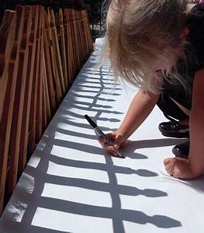 | 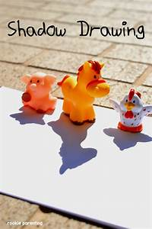 | 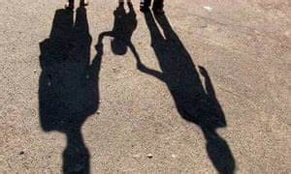 | Shadow Art  Use paper and colours or coloured chalk…..and use your imagination.  I saved this for the last week. I hope Mr Sun shines so that we can get some great shadows.  Try it at different times of the day.
Religion | Grow in Love Second Class  Seasonal Lessons –Lesson 5  Page 62 & 63  Look at the pictures on page 62 & 63. Talk about them. | Grow in Love Second Class  Seasonal Lessons –Lesson 5  Page 62 & 63  Watch the online clips  Our Synagogue  Our Mosque
Music | Go to the Music Generation link at the bottom of the Covid 19 link on our website and check out the materials for Second Class  For Music links – PLEASE, PLEASE, ask your parents/guardians for permission first. |  | Make a list of your 5 favourite songs/pieces of music, and if you can, email them to me. We could make a Second Class top 10!  You have to listen my choice of music during the year, but in June, I have to listen to your choice.  I’m looking forward to hearing your songs.
Don’t forget to check out Music Generation.

We need a summer song. Watch this version of Mr Blue Sky, created by a school in England.
https://www.youtube.com/watch?v=Tv0YVPovn9s

Here’s a version with the lyrics.
https://www.youtube.com/watch?time_continue=23&v=GswbT5zfmRE&feature=emb_logo

Links
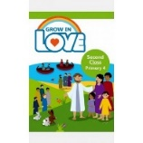
Religion: Register an account with
Grow in Love – use email trial@growinlove.ie Password: growinlove

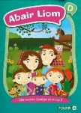
Gaeilge; Register an account with Folens Online - register as a teacher
Use Prim20 as the roll number
Abair Liom B Resources
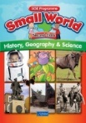
C J Fallon
Go to http://my.cjfallon.ie Click ‘Student Resources’, then filter to the title you require, making sure ‘Online Book’ is selected under ‘Resources’
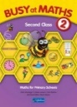
C J Fallon – as above

General Notes
Please refer to March sheet for reading, tables, other activities etc.

Websites
General | www.teachstarter.com  Year 2 School Closure - Learning From Home Pack  A collection of age-appropriate, Year 2 teaching resources  Twinkl Twinkl.ie are offering parents a One Month FREE Ultimate Membership to Twinkl.ie.This will allow parents unlimited access to every single resource for every singleresource for every single curriculum subject from Junior Infants to Sixth Class. Gotowww.twinkl.ie/offer and enter the code IRLTWINKLHELPS.
Gaeilge | Cúla
English | David Walliams daily story Google ‘bit ly audio elevenses’  https://www.storylineonline.net Stories read by famous people  https://wordville.com/ReadingComp/ Online reading comprehension exercises  https://www.wilbooks.com/free-resources-free-online-books-second-grade Free extra reading books  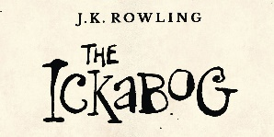  http://class2ab.weebly.com/uploads/8/1/6/5/8165075/stanley.pdf Flat Stanley books  ***J K Rowling***  J K Rowling’s new book is available online.  There is even an illustration competition to do. Check it out www.theickabog.com
Maths | IXL maths Maths & English  Maths is fun – online timed sums Practice your addition, subtraction tables
SPHE | Cosmic kids yoga
Art | Draw with Don: Don Conroy has a You Tube channel where he has lessons to draw different things like owls and clowns.
PE | Go noodle Activities, games, etc  The Body Coach: Joe Wicks has a daily P.E. for Primary School Children which can be followed on The Body Coach You Tube channel.
Various | www.topmarks.co.uk  www.pinterest.com (very good for art ideas)  www.arcademics.com  www.scoilnet.ie

General Activities
RTE Home School Hub RTÉ 2 are showing Home School Hub every weekday at 11 am so tune in for lots of fun learning and activities.
Ted Ed for kids
Daily Mile: Complete your daily mile jogging or walking for 15/20 minutes each day. Do it wherever is safe for you.
Newsflash: There is now an online edition of this magazine available to everyone. There is reading and activities to complete by following the link on the school website www.newsmagmedia.ie Read an at least one article each week and complete an activity.
Spellings/Tables Test: Get one of your parents to ask you your Spellings and Tables at the end of each week and complete in your Spelling Test Copy.

