Good morning Second Class
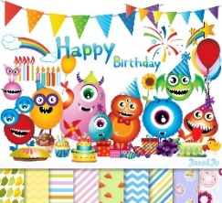
Grace, Ryan K, Ava Helen, Thomas C, Elise, Tom, Bayya, Darragh, Thomas M, Cathal, Liadán, Daibhín, Sophia, Pauraic, Leah, Orlaith, Ryan P, Eimear, Shaynah, Ruby, Emily, Eoghan, Abi, Stephen, Anna, Harry, Emma May, James, Anya, Kallum, Kayleigh, Ava Lily,
****Happy Birthday****
Happy Birthday to Ava Lily Carroll who will be 9 on the 9th of June.

I hope you are all well.
Remember, please ask your parents to send me an email, if they haven’t already done so. My email address is
MTComerfordscn@gmail.com
I will need your parents’ email address for your report. You can also send me an email if you have any questions about your school work. You can also send me a picture of your work, your activities at home, etc….anything that you have achieved that makes you feel really proud.

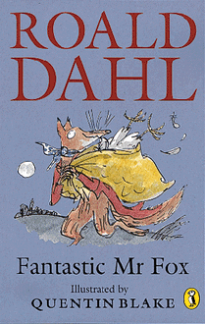
Thank you for your lovely emails.It was wonderful to hear about your activities and great to see your photos. This week send me a photo of the class novel (or books) you are reading/you have finished – remember it’s your choice. Also, give it a mark out of 10. I would give The Twits 10 out of 10. But some books would get a lower mark. You are the judge.

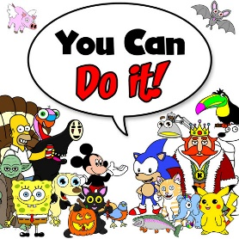
I hope you all had a lovely weekend.
I know it’s difficult in June to do some class work – but keep reading. Every subject needs reading. Also remember your tables and skip-counting – every class (in both primary and secondary school) needs tables!
We have nearly finished all of our school books…………..so keep going……..you can do it!

Second Class: This is your suggested plan of work for this week.
Just try your best – there is no need to worry about not understanding a topic or not finishing any activity.
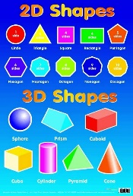
It is very important that
- Wash your hands
- Get some fresh air everyday (within 20 kilometres from your home!!)
- Try to name 10 animals you would find in your neighbourhood .
- BBC Springwatch is back. Go online and watch some of the amazing webcams of birds in their nests. See what the nestlings are going to have for breakfast. Wouldn’t you like a few, juicy worms??
- Read a poem to someone ……….or to yourself.
- Do some mental maths –look for shapes in your home or neighbourhood. We did this exercise in school last year. Remember, look for 2D and 3D shapes. Perhaps you take a photo of 1 of them.
- Stay safe
- Record your learning experiences (1) Academic, (2) Exercise/Fun and (3) Home Chores) in your homework journal everyday
- It’s June – here’s are some jokes for you. Google ‘National Geographic Kids Just Joking LOL’
- Wash your hands
Second Class Week 8– Summer Term
Day | Monday June 8th | Tuesday June 9th | Wednesday June 10th | Thursday June 11th | Friday June 12th
English | Reading  The Green Genie  – Unit 23 – Page 92, 93.  Do answers orally – in your head. |  | Reading  The Green Genie  – Unit 23 – Page 94, 95.  Do answers orally – in your head.  Page 95  Remember  Noun = naming word  cat  Adjective = describing word  lovely cat  Verb = doing word  lovely cat purrs |  | Reading - DEAR  (Drop Everything And Read)
 | Reading/Novel  My Read at Home Book 2 – second class (C J Fallon)  (Read 1 story per day and see if you can answer the questions – orally.) | Reading/Novel  My Read at Home Book 2 – second class (C J Fallon)  (Read 1 story per day and see if you can answer the questions – orally.) | Reading/Novel  My Read at Home Book 2 – second class (C J Fallon)  (Read 1 story per day and see if you can answer the questions – orally.) | Reading/Novel  My Read at Home Book 2 – second class (C J Fallon)  (Read 1 story per day and see if you can answer the questions – orally.) | Class Novel  Don’t forget Fantastic Mr Fox, or your own choice.
 | Reading – Poetry  Poems are great to read. Here is one I read during the week. Kenn Nesbitt is a famous poet.  Why don’t you look for a great poem?  This website might help you.  https://www.poetry4kids.com/ |  | 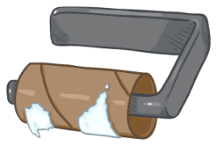  We’re Running Out of Toilet Paper  We’re running out of toilet paper.  Paper towels too.  We haven’t got much Kleenex left.  I’m not sure what we’ll do.  We tried to buy some yesterday.  We went to every shop,  but all the shelves were barren  from the bottom to the top.  We called our friends to see  if they had extra we could borrow,  but they said they have just enough  to last until tomorrow.  Our roll is almost empty now.  A solitary square  is hanging on the holder and  it’s way too small to share.  I hope we find some paper soon  or other kinds of wipers.  If not, I’m told I’ll have to use  my baby brother’s diapers.  — Kenn Nesbitt
 | Spelling  Make sure you know how to spell your full name and address, and make sure you can spell the names and addresses of all the important people in your family. | Spelling  Same as Monday | Spelling  Same as Monday | Spelling  Same as Monday | Test yourself
Handwriting
- Page 62
 |  | Writing  ‘My Dream School Tour’  In June we usually go on a school tour.  This year we are going on a school tour in our imagination.  Write about your dream school tour. | Writing  Check your writing from yesterday. | Writing  Illustrate your dream school tour | https://virtualschoolactivities.com/  You can google virtual school tours. This website has a list of them. Or just look at Dublin Zoo.
Gaeilge | Abair Liom D Unit 29 –Le foghlaim 1 140.  Complete the sentences | Abair Liom D Unit 29 –Le foghlaim 1 | Abair Liom D Unit 29 –Le foghlaim 1 141  Complete the sentences. | Abair Liom D Unit 29 –Le foghlaim 1 | Abair Liom D Unit 29 –Le foghlaim 1
 | Online Game - 29 – Le foghlaim 1 - Pléasc an Balún - Le foghlaim 1
 | 1 o’clock A haon a chlog  2 o' clock A dó a chlog  3 o' clock A trí a chlog  4 o' clock A ceathair a chlog  5 o' clock A cúig a chlog  6 o' clock A sé a chlog  7 o' clock A seacht a chlog  8 o' clock A hocht a chlog  9 o' clock A naoi a chlog  10 o' clock A deich a chlog  11 o' clock A haon déag a chlog  12 o' clock A dó dhéag a chlog |  | Ag súgradh – playing  Ag léamh – reading  Ag obair – working  Ag ithe – eating  Ag canadh – singing  Ag rith – running  Ag gáire – laughing  Ag taitneamh – shining  Ag siúl – walking  Ag léim - jumping
 | **Optional**  Reading/Leitheoireacht  C J Fallon  Léigh sa Bhaile Leabhar B  Online Book  Léigh sa Bhaile B - Rian/Lch 3 – there is also an audio file so you can listen to the story. |  | **Optional**  Reading/Leitheoireacht  C J Fallon  Léigh sa Bhaile Leabhar B  Online Book  Léigh sa Bhaile B - Rian/Lch 4 –  there is also an audio file so you can listen to the story.
Maths | Busy at Maths 2 – Page 159 – Two-step problems – Bigger numbers  Weblink - Activity 159A - Page 159  Remember we always do the brackets first. | Busy at Maths 2 – Page 160 – Two-step problems – Plus or minus  Weblink - Activity 160A - Page 160  Read the problem.  Underline the important words. | Busy at Maths 2 – Page 161 – Two-step number problems A  Weblink - Activity 161A - Page 161  This is just another way to do 2-step problems.  Look at the example. | Busy at Maths 2 – Page 162 – Two-step number problems B  Weblink - Activity 162A - Page 162  Remember we always do the brackets first. | **Optional**  C J Fallon website.  Master Your Maths 2 – Week 25 Test  – page 90  There is an answer booklet available on the same website.
 | Tables Revise Subtraction -3.  Start at 95, subtract 3, keep going, until you reach 0 or near 0 | Tables Revise Subtraction -3.  Start at 100, subtract 3, keep going, until you reach 0 or near 0 | Tables Revise Subtraction -3.  Look at 100 square in hard back copy. Close your eyes, put your finger on number, subtract 3 | Tables Revise Subtraction -3.  Ask a member of your family to call out a number, you subtract 3 as fast as you can. | Tables Test
 | Counting in 4s to 40  4, 8, 12, 16, 20, 24, 28, 32, 36, 40. | Can you count in 40s?  How far can you go? | Counting in 5s to 50  5, 10, 15, 20, 25, 30, 35, 40, 45, 50 | Can you count in 50s?  How far can you go? | Check that you can do your counting in 4s and 5s perfectly.
 | Try https://www.topmarks.co.uk/maths-games/hit-the-button for maths games.
P.E |  |  | Joe WICKS/Gonoodle/  Cosmic Yoga | Remember 10 at 10????  https://www.youtube.com/watch?time_continue=1&v=vaWSjY8jkoI&feature=emb_logo | SUPER YOGA – Spooky Spectacular – Cosmic Kids Zen Den  (Online)
SESE (Hist./  Geog./  Science) | (Note – Small World may be used as reading material) | Small World 2nd Class –  Page 94 – Why do we need electricity?  Read and complete page 94 in your book. |  | Small World 2nd Class –  Page 95 – What is Electricity?  Read page 95 and complete the exercise in your book.
Art | Family Hand Print |  | 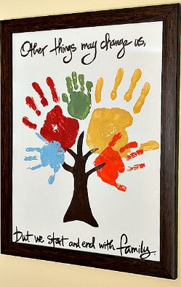 | Your family will love this one!! Get everyone’s hand print in your family and create a picture. Here are some examples.  Don’t worry if you haven’t any paint (or the grown-ups think it’s too messy!!) – draw around their hands and colour them in.  Don’t forget to insert the date.
Religion | Grow in Love Second Class  Seasonal Lessons –Lesson 3  Page 58 - Jesus in the desert  Read the story and put the missing word in each space. Use the Word Bank at the bottom of the page.  Watch the clips –‘Jesus in the desert’ online. | Grow in Love Second Class  Seasonal Lessons –  Page 59 - Lent  Remember what you did for Lent?  Complete each circle  We can give up…  We can pray…..  We can share…. | Grow in Love Second Class  Seasonal Lessons –Lesson 4  Page 61 – Saint Brigid builds her church.  Read the story with your family.  Watch the clip ‘ St Brigid builds her church’ online. | Grow in Love Second Class  Seasonal Lessons –  Page 60 – Saint Brigid’s cloak  Colour the picture.
Music | Go to the Music Generation link at the bottom of the Covid 19 link on our website and check out the materials for Second Class  For Music links – PLEASE, PLEASE, ask your parents/guardians for permission first. |  | https://musiclab.chromeexperiments.com/Song-Maker/  Have fun creating your own music.
Don’t forget to check out Music Generation.

This song is so cute. Sesame Street: Andrea Bocelli's Lullaby To Elmo. It is based on that lovely song ‘Time to say goodbye’. Here is the link
https://www.youtube.com/watch?v=5BDVvB7Xx1w

Links
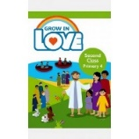
Religion: Register an account with
Grow in Love – use email trial@growinlove.ie Password: growinlove

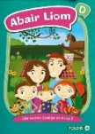
Gaeilge; Register an account with Folens Online - register as a teacher
Use Prim20 as the roll number
Abair Liom B Resources
C J Fallon
Go to http://my.cjfallon.ie Click ‘Student Resources’, then filter to the title you require, making sure ‘Online Book’ is selected under ‘Resources’
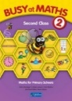
C J Fallon – as above

General Notes
Please refer to March sheet for reading, tables, other activities etc.

Websites
General | www.teachstarter.com  Year 2 School Closure - Learning From Home Pack  A collection of age-appropriate, Year 2 teaching resources  Twinkl Twinkl.ie are offering parents a One Month FREE Ultimate Membership to Twinkl.ie.This will allow parents unlimited access to every single resource for every singleresource for every single curriculum subject from Junior Infants to Sixth Class. Gotowww.twinkl.ie/offer and enter the code IRLTWINKLHELPS.
Gaeilge | Cúla
English | David Walliams daily story Google ‘bit ly audio elevenses’  https://www.storylineonline.net Stories read by famous people  https://wordville.com/ReadingComp/ Online reading comprehension exercises  https://www.wilbooks.com/free-resources-free-online-books-second-grade Free extra reading books  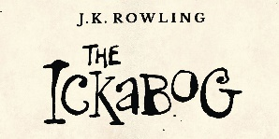  http://class2ab.weebly.com/uploads/8/1/6/5/8165075/stanley.pdf Flat Stanley books  ***J K Rowling***  J K Rowling’s new book is available online.  There is even an illustration competition to do. Check it out www.theickabog.com
Maths | IXL maths Maths & English  Maths is fun – online timed sums Practice your addition, subtraction tables
SPHE | Cosmic kids yoga
Art | Draw with Don: Don Conroy has a You Tube channel where he has lessons to draw different things like owls and clowns.
PE | Go noodle Activities, games, etc  The Body Coach: Joe Wicks has a daily P.E. for Primary School Children which can be followed on The Body Coach You Tube channel.
Various | www.topmarks.co.uk  www.pinterest.com (very good for art ideas)  www.arcademics.com  www.scoilnet.ie

General Activities
RTE Home School Hub RTÉ 2 are showing Home School Hub every weekday at 11 am so tune in for lots of fun learning and activities.
Ted Ed for kids
Daily Mile: Complete your daily mile jogging or walking for 15/20 minutes each day. Do it wherever is safe for you.
Newsflash: There is now an online edition of this magazine available to everyone. There is reading and activities to complete by following the link on the school website www.newsmagmedia.ie Read an at least one article each week and complete an activity.
Spellings/Tables Test: Get one of your parents to ask you your Spellings and Tables at the end of each week and complete in your Spelling Test Copy.
.

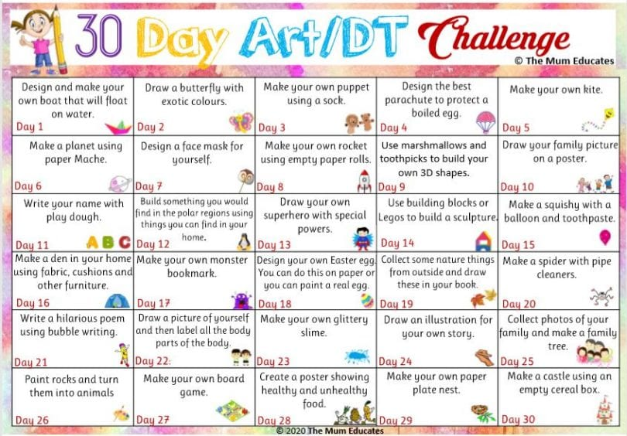
Perhaps you could try some of these activities.

