Good morning

Ava Helen, Tom, Bayya, Thomas M, Daibhín, Sophia, Eimear, Ruby, Emily, Eoghan, Abi, Harry, James, Anya, Kallum, Kayleigh, Ava Lily, Leah, Liadán, Cathal, Orlaith, Pauraic, Darragh, Ryan K, Elise, Ryan P, Shaynah, Emma May, Stephen, Grace, Thomas C, Anna,

I hope you are all well.
Remember, please ask your parents to send me an email, if they haven’t already done so. My email address is
MTComerfordscn@gmail.com
I will need your parents’ email address for your report. You can also send me an email if you have any questions about your school work. You can also send me a picture of your work, your activities at home, etc…….anything that you have achieved that makes you feel really proud.
Thank you for your lovely emails.It was wonderful to hear about your activities and great to see your photos.
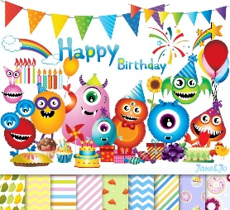
****Happy Birthday****
Happy Birthday to Kayleigh Strickland who was 9 years old on Sunday.
Happy Birthday to Thomas Moore who will be 9 years old on Thursday.
Happy Birthday to Abi Mulvin who will be 9 years old on Saturday.

I hope you all had a lovely weekend. I will see you all in September and please God, we will celebrate our First Holy Communion at some stage.
I know the weather is lovely and it may be difficult to do some class work – but keep reading. Every subject needs reading. Also remember your tables and skip-counting – every class (in both primary and secondary school) needs tables!

Second Class: This is your suggested plan of work for this week.
Just try your best – there is no need to worry about not understanding a topic or not finishing any activity.

It is very important that
- Wash your hands
- Get some fresh air everyday (within 5 kilometres from your home!!)
- Try and name 5 birds that fly into your garden or neighbourhood.
- BBC Springwatch is back. Go online and watch some of the amazing webcams of birds in their nests. See what the nestlings are going to have for dinner.
- Read a story to someone ……….or to yourself.
- Are there any planets visible in the sky at the moment?
- Wash your hands
- Do some mental maths –remember tally marks? Stand at your window. Do a little survey of traffic or people or birds passing by. Remember to do your tally marks in groups of 5.
Remember, you have to time your survey. 10 minutes may be enough.
- Stay safe
- Record your learning experiences (1) Academic, (2) Exercise/Fun and (3) Home Chores) in your homework journal everyday
- Wash your hands

Second Class Week 5 – Summer Term
Day | Monday June 1st | Tuesday June 2nd | Wednesday June 3rd | Thursday June 4th | Friday June 5th
English | Bank Holiday | School Holiday | Reading  The Green Genie  – Unit 22 – Page 88, 89.  Do answers orally – in your head. | Reading  The Green Genie  – Unit 22 – Page 90, 91.  Page 91. Contractions are important.  We take out a letter and insert an apostrophe.  I am = I’m  Write answers in your copybook – Activity B and C. | Reading - DEAR  (Drop Everything And Read)
 |  |  | Reading/Novel  My Read at Home Book 2 – second class (C J Fallon)  (Read 1 story per day and see if you can answer the questions – orally.)  Here is another book from storylineonline.  https://www.storylineonline.net/books/zombies-dont-eat-veggies/  Make a note of what you thought of the story. | Reading/Novel  My Read at Home Book 2 – second class (C J Fallon)  (Read 1 story per day and see if you can answer the questions – orally.)  Story line online has lots of books that are read by famous people.  Did you read any others? Write down the titles and give them a mark out of 10. | Class Novel  Don’t forget Fantastic Mr Fox, or your own choice.
Tongue Twister – some fun reading.
Through three cheese trees three free fleas flew.
While these fleas flew, freezy breeze blew.
Freezy breeze made these three trees freeze.
Freezy trees made these trees' cheese freeze.
That's what made these three free fleas sneeze.―
Dr. Seuss.
 |  |  | Spelling Made Fun C – Unit 32 | Spelling Made Fun C – Unit 32 – | Test  More sad news – you have finished your Spelling Made Fun. Well done. Give yourself a pat on your back.
Handwriting
- Page 61
 |  |  | Writing  ‘My Communion Day in Quarantine’  or  ‘A Memorable Day’  Last Saturday, should have been a very important day in your life. But I am sure you had a great day. Write about last Saturday. Maybe you cooked a special dinner with your family……or perhaps you went for a cycle on your bike……or….??  If you would prefer to write about a different day, that’s fine. | Writing  Put on your teacher hat and check yesterday’s piece of writing.  Spellings?  Capital letters?  Full stops?  Sentences?  Read it aloud. Does its sound correct?  Is there anything you could add? | Writing
Gaeilge |  |  | Abair Liom D Unit 28 – Súil Siar 4 –  138  A – label the pictures, pick one of these words.  – siosúr  dréimire  sábh..  glasraí  fidil…  ……spád..  B – answers in coloured boxes beside picture/  Rinne – Made/Did  Ní dhearna – I didn’t do/make  Tá cabhair uaim – I need help  Níl cabhair uaim – I don’t need help | Abair Liom D Unit 28 – Súil Siar 4 – 139  C – Circle the differences  B – write the sentence correctly – the words are mixed up. | Abair Liom D Unit 29 – Súil Siar 4 –  138, 139  Revision
Online Game -
28 – Súil Siar 4
Pléasc Uisce - Súil siar 4
Cluiche chun dul siar ar an bhfoclóir ó Cheachtanna 22-26.

 |  |  | Reading/Leitheoireacht  C J Fallon  Léigh sa Bhaile Leabhar B  Online Book  Léigh sa Bhaile B - Rian/Lch 1 – there is also an audio file so you can listen to the story. | Reading/Leitheoireacht  C J Fallon  Léigh sa Bhaile Leabhar B  Online Book  Léigh sa Bhaile B - Rian/Lch 2 –  there is also an audio file so you can listen to the story.
 |  |  | Fuaimeanna & Focail | Fuaimeanna & Focail
Maths |  |  | Busy at Maths 2 – Page 157 – Two-step number problems (mental) 1  Weblink - Activity 157A - Page 157 | Busy at Maths 2 – Page 158 – Two-step number problems (mental) 2  Weblink - Activity 158A - Page 158 | **Optional**  C J Fallon website.  Master Your Maths 2 – Week 20 Test  – page 85  There is an answer booklet available on the same website.
 |  |  | Tables Revise Subtraction -4.  Start at 97, subtract 4, keep going, until you reach 0 or near 0 | Tables Revise Subtraction -4.  Look at 100 square in hard back copy. Close your eyes, put your finger on number, subtract 4. | Tables Revise Subtraction -4.  Ask a member of your family to call out a number, you subtract 4 as fast as you can.
 |  |  | Counting in 2s to 20  2, 4, 6, 8, 10, 12, 14, 16, 18, 20 | Counting in 20s to 100.  Can you see a short cut? | Counting in 2s.  Start at 40. Can you count backwards in 2s?
Mathsweek Target Boards
Google Mathsweek Target Boards
You will need this code Scoil Chroi Naofa, Rochfortbridge , Class: Second Class : Code: ZXW4493
Scroll down to GO TO TARGET BOARDS
Go to Junior section – scroll down for **Active** page
You have to make the target number, using the numbers in the square.
 | Try https://www.topmarks.co.uk/maths-games/hit-the-button for maths games.
P.E |  |  | Joe WICKS/Gonoodle/  Cosmic Yoga | Remember 10 at 10????  https://www.youtube.com/watch?time_continue=1&v=vaWSjY8jkoI&feature=emb_logo | The Listening Game – Cosmic Kids Zen Den  (Online)
SESE (Hist./  Geog./  Science) | (Note – Small World may be used as reading material) |  | Small World 2nd Class –  Page 92 – Communication  Read and complete page 92 orally. | Small World 2nd Class –  Page 93 - Communication  Read and complete page 93.
Art |  |  |  |  | See Ferocious Creatures on page 8
Religion |  |  | Grow in Love Second Class  Seasonal Lessons –  Page 56 - St Vincent de Paul  Lesson 2: Celebrating the Saints (1 November) – watch the clips on St Vincent de Paul. | Grow in Love Second Class  Seasonal Lessons – Page 57 -All Saints, All Souls
Music | Go to the Music Generation link at the bottom of the Covid 19 link on our website and check out the materials for Second Class  For Music links – PLEASE, PLEASE, ask your parents/guardians for permission first. |  | The Right Note  Page 77  Colour in the pictures of the jungle.  The music we need is not online, but you could listen to this one…..  https://www.youtube.com/watch?v=rVgIZ_-akvw&feature=emb_logo Down in the jungle | The Right Note  Page 78  Last week and this week, you listened to the March of the Lion.  Complete page 78 | ‘Everyday is a school day!!’ – I never knew Katie Perry’s song Roar is from the new Disney Jungle Book. Have a listen here.  https://www.youtube.com/watch?time_continue=116&v=IVeodoLmhPg&feature=emb_logo
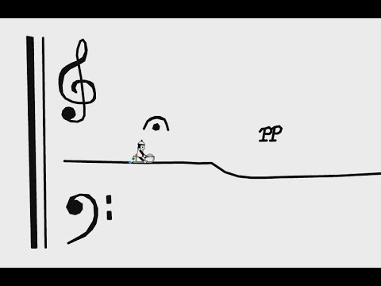
I am sure you were very busy last week. Look at Music Generation for last week. It featured ‘In the hall of the mountain king’. It has some lovely clips, including the story of Peer Gynt. You all know the famous Line Rider piece ‘In the hall of mountain king’.

Think Mr Line Rider was busy while we were away. Here is one he created based on the Harry Potter theme.
https://www.youtube.com/watch?time_continue=59&v=KgLMhr-FVgE&feature=emb_logo

Links
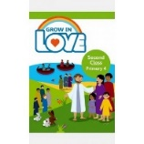
Religion: Register an account with
Grow in Love – use email trial@growinlove.ie Password: growinlove

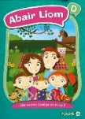
Gaeilge; Register an account with Folens Online - register as a teacher
Use Prim20 as the roll number
Abair Liom B Resources
C J Fallon
Go to http://my.cjfallon.ie Click ‘Student Resources’, then filter to the title you require, making sure ‘Online Book’ is selected under ‘Resources’
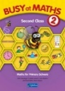
C J Fallon – as above

General Notes
Please refer to March sheet for reading, tables, other activities etc.

Websites
General | www.teachstarter.com  Year 2 School Closure - Learning From Home Pack  A collection of age-appropriate, Year 2 teaching resources  Twinkl Twinkl.ie are offering parents a One Month FREE Ultimate Membership to Twinkl.ie.This will allow parents unlimited access to every single resource for every singleresource for every single curriculum subject from Junior Infants to Sixth Class. Gotowww.twinkl.ie/offer and enter the code IRLTWINKLHELPS.
Gaeilge | Cúla
English | David Walliams daily story Google ‘bit ly audio elevenses’  https://wordville.com/ReadingComp/ Online reading comprehension exercises  https://www.wilbooks.com/free-resources-free-online-books-second-grade Free extra reading books  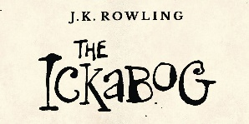  http://class2ab.weebly.com/uploads/8/1/6/5/8165075/stanley.pdf Flat Stanley books  ***J K Rowling***  J K Rowling’s new book is available online.  There is even an illustration competition to do. Check it out www.theickabog.com
Maths | IXL maths Maths & English  Maths is fun – online timed sums Practice your addition, subtraction tables
SPHE | Cosmic kids yoga
Art | Draw with Don: Don Conroy has a You Tube channel where he has lessons to draw different things like owls and clowns.
PE | Go noodle Activities, games, etc  The Body Coach: Joe Wicks has a daily P.E. for Primary School Children which can be followed on The Body Coach You Tube channel.
Various | www.topmarks.co.uk  www.pinterest.com (very good for art ideas)  www.arcademics.com  www.scoilnet.ie

General Activities
RTE Home School Hub RTÉ 2 are showing Home School Hub every weekday at 11 am so tune in for lots of fun learning and activities.
Ted Ed for kids
Daily Mile: Complete your daily mile jogging or walking for 15/20 minutes each day. Do it wherever is safe for you.
Newsflash: There is now an online edition of this magazine available to everyone. There is reading and activities to complete by following the link on the school website www.newsmagmedia.ie Read an at least one article each week and complete an activity.
Spellings/Tables Test: Get one of your parents to ask you your Spellings and Tables at the end of each week and complete in your Spelling Test Copy.
Surprise Ferocious Beings Paper Project For 2020  (I saw this project on a different website. I have copied out the instructions here, but check out the website below. There are lots of ads on the page which are so annoying!!)  https://craftwhack.com/surprise-ferocious-beings-paper-project/ | 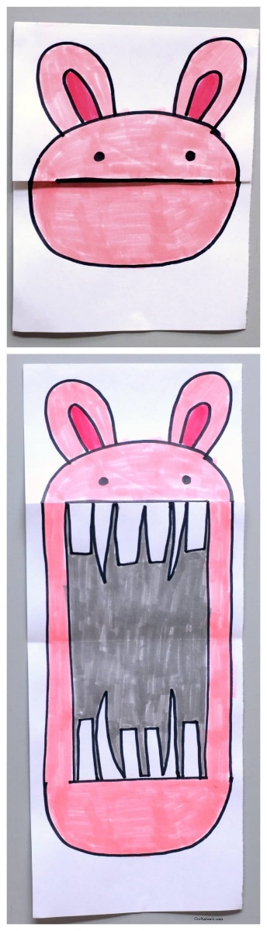  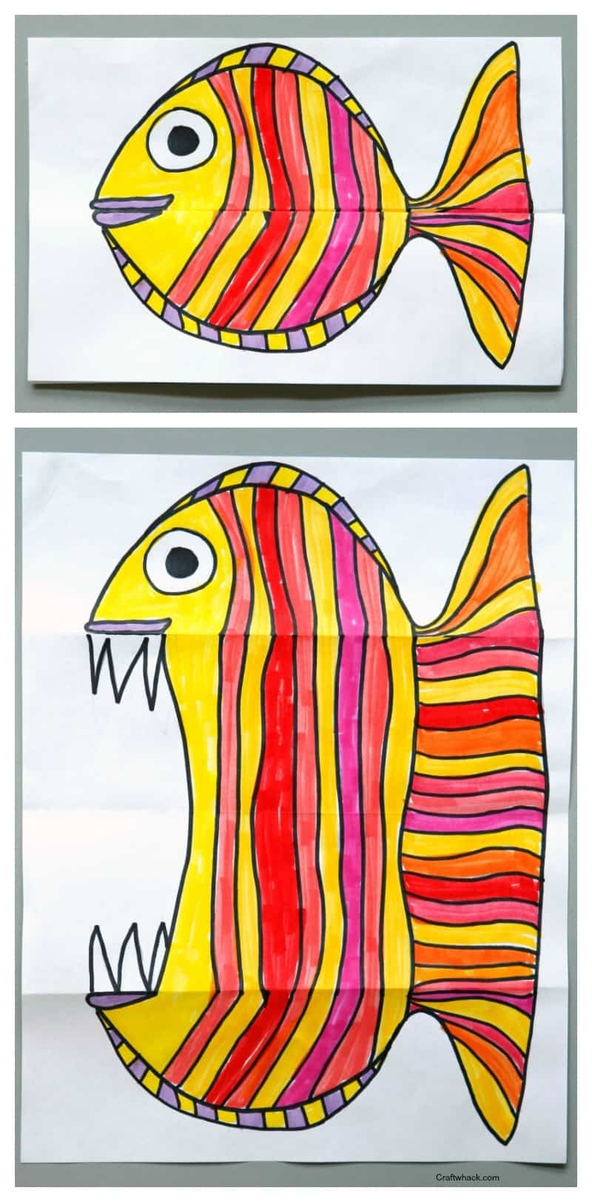
Materials:  Paper –  Pencil  Black Sharpie  Markers | Directions:  1 Fold your piece of paper in half, widthwise.  2 Fold back one or both of the two edges opposite from the first fold. What? How do I explain this…. here. just look:  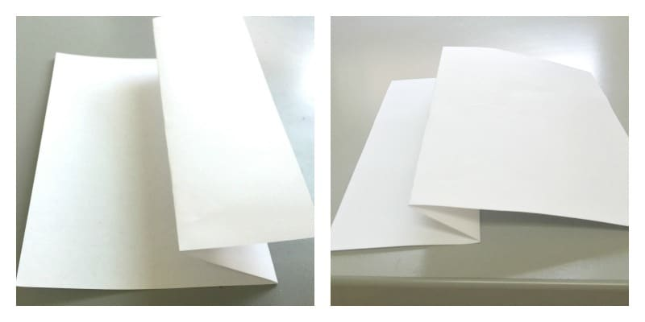  Draw your sweet, gentle animal with pencil on the folded paper, being careful where the folds are: you want to make sure the mouth looks good closed, but that it also will look terrifyingly fierce when you open up the paper.

