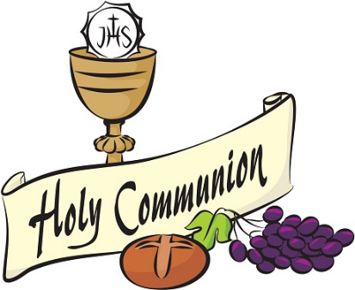
Good morning
Tom, Thomas M, Thomas C, Stephen, Sophia, Shaynah, Ryan P, Ryan K, Ruby, Pauraic, Orlaith, Liadán, Leah, Kayleigh, Kallum, James, Harry, Grace, Eoghan, Emma May, Emily, Elsie, Eimear, Darragh, Daibhín, Cathal, Bayya, Ava Lily, Ava Helen, Anya, Anna, Abi

I hope you are all well.
Thank you for your lovely emails.It was wonderful to hear about your activities and great to see your photos. My email address is
MTComerfordscn@gmail.com

Remember, I will need your parents’ email address for your report. You can also send me an email if you have any questions about your school work. You can also send me a picture of your work, your activities at home, etc…….anything that you have achieved that makes you feel really proud.

Second Class: This is your suggested plan of work for this week.
This should have been a very special week for you all. I have written a special note in Thursday’s and Friday’s slot.
Just try your best – there is no need to worry about not understanding a topic or not finishing any activity.

It is very important that
- Wash your hands
- Get some fresh air everyday (within 5 kilometres from your home!!)
- This is our special week. On Thursday and Friday, be nice to yourselves. Read your book, water the flowers, lie on your back and look at the shapes the clouds make in the sky, go for another walk - I know you can think of many more activities and …………..smile.
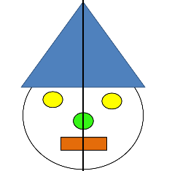
- Get a deck of cards and play SNAP.
- Wash your hands
- Do some mental maths –remember symmetry?? Look for items around your house/garden that are symmetrical. Draw some of the items in your copybook.
- Stay safe
- Record your learning experiences (1) Academic, (2) Exercise/Fun and (3) Home Chores) in your homework journal everyday
- Wash your hands

Second Class Week 5 – Summer Term
Day | Monday May 25th ^{h} | Tuesday May 26th | Wednesday May 27th | Thursday May 28th | Friday May 29th
English | Reading  The Green Genie – Unit 21 – Page 84, 85.  Do answers orally – in your head. | Reading – SESE book 87-89 | Reading  The Green Genie  Unit 21 – Page 86 -do answers orally – in your head.  Page 87 – write answers in your copy. | Reading – DEAR (Drop Everything And Read)
 | Reading  My Read at Home Book 2 – second class (C J Fallon)  (Read 1 story per day and see if you can answer the questions – orally.) | Reading  My Read at Home Book 2 – second class (C J Fallon)  (Read 1 story per day and see if you can answer the questions – orally.) | Reading  My Read at Home Book 2 – second class (C J Fallon)  (Read 1 story per day and see if you can answer the questions – orally.) | Dear Second Class  Saturday was supposed to have been your First Communion Day, which would have been a very special day for you all.  Unfortunately, we are not getting the chance to celebrate together, to see you all looking so well in your fine clothes, to listen to you as you say the prayers you prepared so well in class and at home. We won’t get to see the proud smiles of your parents, families and friends who would have come to support you and share in your celebration.  We won’t get a chance to sing along with our wonderful choir and enjoy the cup of tea in the school afterwards.  But this special time will come and it will be filled with excitement, happy smiles and laughter.  In this month of May, we’ll say a prayer to Mary, mother of Jesus, to keep us all safe and in her care.  On Saturday, I will light a candle at 11am and think of you all.  Hope you have a lovely weekend with your families.  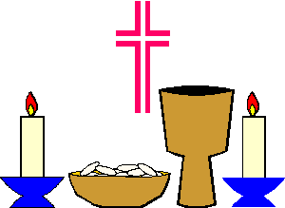  .
 | Novel  Think about a novel you would like to read.  Read it online or borrow a book.  If you can’t think of one, download ‘Fantastic Mr Fox’ from school website and read it at home.  Fantastic Mr Fox pdf | Novel | Novel
Tongue Twister – some fun reading

Luke Luck likes lakes,
Luke's duck likes lakes,
Luke Luck licks lakes,
Luke's duck licks lakes,
Duck takes licks in lakes Luke Luck likes,
Luke Luck takes licks in lakes duck likes.

 | Spelling Made Fun C – Unit 31 - Page 100, 101 | Spelling Made Fun C – Unit 31 – Page 102 | Spelling Made Fun C – Unit 30 – Page 103
 |  | Handwriting  - Page 59 | Handwriting  - Page 60
 | Writing  Write your news.  I know you wrote about your experiences during Lockdown, earlier this month.  What have you done since this?  I know some of you have been busy playing chess, painting rocks, working on the bog, learning about the Titanic, walking the dog, riding your bicycle, doing projects, baking…..and so on…  Don’t forget when you’re finished, put on your teacher hat and check your spellings, capital letters etc. Read it aloud. Does it sound correct? | Writing  Check your news. Is there anything else to write about?  Draw a picture about it. | Writing  The Green Genie page 83
Gaeilge | Abair Liom D Unit 27 – An Béar Bán agus an Béar Mór - 136, 137 (Section B)  Online resource – click on Scéal - An Béar Beag agus an Béar Mór  Just listen to the story. | Abair Liom D Unit 27 – An Béar Bán agus an Béar Mór - 136, 137 (Section B)  Online resource – click on Scéal - An Béar Beag agus an Béar Mór  Just listen to the story. | Abair Liom D Unit 27 – An Béar Bán agus an Béar Mór - 136, 137 (Section B)  Online resource – click on Scéal - An Béar Beag agus an Béar Mór  Just listen to the story.
 | Reading/Leitheoireacht  Abair Liom D Unit 27 | Reading/Leitheoireacht  Abair Liom D Unit 27 | Reading/Leitheoireacht  Abair Liom D Unit 27
 | Fuaimeanna & Focail | Fuaimeanna & Focail | Fuaimeanna & Focail
Maths | Busy at Maths 2 –  Page 154 – Subtraction 4 – Renaming C  Subtraction with renaming is difficult. Try to follow the example – shorter way on the top of page 153. Don’t worry if you cannot complete the page, or if you don’t understand it. Your teacher will revise this with you, next September.  Weblink - Activity 154A - Page 154 | Busy at Maths 2 – Page 155 – Addition and Subtraction (Revision)  WATCH the signs  Weblink - Activity 155A - Page 155 | Busy at Maths 2 – Page 156 – A quick look back  Revision.  Draw a picture of the problem if you are stuck.  Weblink - Activity 156A - Page 156
 | Tables: Revise Subtraction -5.  Start at 89, subtract 5, keep going, until you reach 0 or near 0 | Tables Revise Subtraction -5.  Start at 94, subtract 5, keep going, until you reach 0 or near 0 | Tables Revise Subtraction -5.  Ask a member of your family to call out a number, you subtract 5 as fast as you can.
 | Counting in 10s to 100  10, 20, 30, 40, 50, 60, 70, 80, 90, 100 | Counting in 10s to 100 . Today start at 100, count back in 10s to 0. | Counting in 10s.  Start at 3, keep adding 10 until you reach 103.
A little reminder
Brainteasers 2 – this book should have been finished before Easter.
Mathsweek Target Boards
Google Mathsweek Target Boards
You will need this code Scoil Chroi Naofa, Rochfortbridge , Class: Second Class : Code: ZXW4493
Go to Junior section – scroll down for **Active** page
You have to make the target number, using the numbers in the square.
 | Try https://www.topmarks.co.uk/maths-games/hit-the-button for maths games.
P.E |  | Joe WICKS/Gonoodle/  Cosmic Yoga | Remember 10 at 10????  https://www.youtube.com/watch?time_continue=1&v=vaWSjY8jkoI&feature=emb_logo
SESE (Hist./  Geog./  Science) | (Note – Small World may be used as reading material)  Small World 2nd Class - Page 90 – Theme Space Travel  Read and complete page 90 |  | Small World 2nd Class –  Page 91 – Theme – Space – Travel.  Read and complete Section C.  Do Section B orally (in your head).
Art | 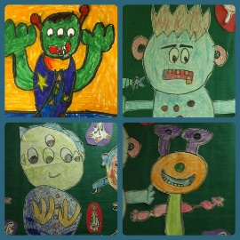  Crazy Aliens | Use your imagination | Draw or create something you might see in space – use recycled materials, look in your recycling bin, go outside, look at leaves, stones etc  This could be a planet or a spaceship……….or a crazy alien……..use your imagination…..
Religion | Grow in Love Second Class | Grow in Love Second Class  Seasonal Lessons - Lesson 1 The Rosary  Page 54 – Praying the Rosary.  Watch the clip – The Rosary – Our family album.  Watch the clip – Hail Mary | Grow in Love Second Class  Seasonal Lessons – Lesson 1 – The Rosary.  Page 55 - The Joyful Mysteries of the Rosary  Complete page 55  Watch the clip – The Joyful Mysteries of the Rosary.
Music | Go to the Music Generation link at the bottom of the Covid 19 link on our website and check out the materials for Second Class  For Music links – PLEASE, PLEASE, ask your parents/guardians for permission first. |  | This is a great song with farm animals playing musical instruments.  https://www.youtube.com/watch?v=0Pm9_M-94XY&feature=emb_logo  Sandra Boynton’s PHILADELPHIA CHICKENS The Bacon Brothers
Classical music is so important. Here is a very ‘royal’ piece about a very regal animal.
https://www.youtube.com/watch?v=VgDvsW9IfE4
Camille SAINT-SAENS - The Carnival of the Animals (I): LION Royal March/Marche Royale du Lions

Links
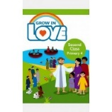
Religion: Register an account with
Grow in Love – use email trial@growinlove.ie Password: growinlove

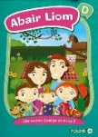
Gaeilge; Register an account with Folens Online - register as a teacher
Use Prim20 as the roll number
Abair Liom B Resources
C J Fallon
Go to http://my.cjfallon.ie Click ‘Student Resources’, then filter to the title you require, making sure ‘Online Book’ is selected under ‘Resources’
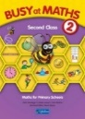
C J Fallon – as above

General Notes
Please refer to March sheet for reading, tables, other activities etc.

Websites
General | www.teachstarter.com  Year 2 School Closure - Learning From Home Pack  A collection of age-appropriate, Year 2 teaching resources  Twinkl Twinkl.ie are offering parents a One Month FREE Ultimate Membership to Twinkl.ie.This will allow parents unlimited access to every single resource for every singleresource for every single curriculum subject from Junior Infants to Sixth Class. Gotowww.twinkl.ie/offer and enter the code IRLTWINKLHELPS.
Gaeilge | Cúla
English | David Walliams daily story Google ‘bit ly audio elevenses’  https://wordville.com/ReadingComp/ Online reading comprehension exercises  https://www.wilbooks.com/free-resources-free-online-books-second-grade Free extra reading books  http://class2ab.weebly.com/uploads/8/1/6/5/8165075/stanley.pdf Flat Stanley books  New*******https://moli.ie/category/bright-sparks-creative-bursts/ - different ideas for writing
Maths | IXL maths Maths & English  Maths is fun – online timed sums Practice your addition, subtraction tables
SPHE | Cosmic kids yoga
Art | Draw with Don: Don Conroy has a You Tube channel where he has lessons to draw different things like owls and clowns.
PE | Go noodle Activities, games, etc  The Body Coach: Joe Wicks has a daily P.E. for Primary School Children which can be followed on The Body Coach You Tube channel.
Various | www.topmarks.co.uk  www.pinterest.com (very good for art ideas)  www.arcademics.com  www.scoilnet.ie

General Activities
RTE Home School Hub RTÉ 2 are showing Home School Hub every weekday at 11 am so tune in for lots of fun learning and activities.
Ted Ed for kids
Daily Mile: Complete your daily mile jogging or walking for 15/20 minutes each day. Do it wherever is safe for you.
St. Mary’s GAA are doing a 30 Day Challenge for funds for Mullingar and Tullamore Hospitals which you can do daily. (Many of you may be already taking part)
Newsflash: There is now an online edition of this magazine available to everyone. There is reading and activities to complete by following the link on the school website www.newsmagmedia.ie Read an at least one article each week and complete an activity.
Spellings/Tables Test: Get one of your parents to ask you your Spellings and Tables at the end of each week and complete in your Spelling Test Copy. No tests this week.

