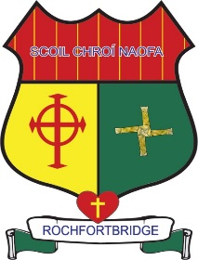

Scoil Chroí Naofa
Rochfortbridge, Co. Westmeath
e-mail: scoilchroinaofarb@gmail.com
Phone: (044)9222389

10/05/2020
Dear Parents / Guardians,
I am again writing to you via the website due to the continued closure of schools. As you are probably aware, the school will not be re-opening this school year, due to the ongoing Covid-19 Health Emergency. As this situation continues, the safety and health of all our families is to the forefront of our thoughts. Please remember the vital importance of Social and Physical distancing and correct handwashing and coughing techniques.

I am sure some of our pupils are confused as to why they cannot come back to school. Please comfort and assure them that school will re-open again and that we look forward to welcoming them back. Check back over our SEN link on our website to find social stories which cover this topic and provide reassurance in a child friendly way. I would like to thank you again for supporting your child’s education at home over the past while. It has been wonderful to hear of our pupils learning new skills such as learning to cycle a bike, baking, taking care of animals and even hair cutting!

Work-plans continue to be posted on our website each week. We are acutely aware that each child learns in different ways. Please decide according to the ability/needs/circumstances of your household which school activities your child can complete. Remember reading with your child, praising their work, speaking with your child, experiencing nature and keeping healthy at this time is of equal importance.

Included in next week plans (dated 18th – 22nd May) each teacher will provide you with an email address. When you receive the email details please email your teacher stating your child’s name so as we have your up to date contact details. You and your child may write to their teacher and attach photos etc. of work they are most proud of.

This year due to the coronavirus pandemic and for your health and safety we will be emailing your child/ren’s end of year report. Please send your child’s class teacher an email stating you consent to this method of communication otherwise be advised that reports will be only available in September when we return to school. Please also note that there will be no standardised Test scores on the report as they have been cancelled for this year.

I am attaching a copy of our school calendar for the school year 2020/2021 to this message. It may be of use to those of you wishing to rebook cancelled holidays for this year.

Our school twitter account remains another way in which you and your children can engage with school. Please follow us on twitter by searching @SNaofa for news, updates and fun activities. In the midst of this uncertain time please keep the positivity flowing by tweeting us your good news each Friday.

Finally, on behalf of all of us in Scoil Chroí Naofa, I wish you well, stay healthy and stay apart.

Le meas,
Kathleen McNamee
Principal

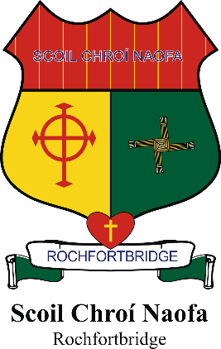

School Calendar 2020-2021

School re-opens | Monday 31st August 2020
Mid-term | School closes on Friday 23rd October 2020  School reopens on Monday 2nd November 2020
Christmas Holidays | School closes on Tuesday 22nd December 2020 at 12 pm  School reopens on Wednesday 6th January 2021
Mid-term | School closes Friday 12th February 2021  School reopens on Monday 22nd February 2021
St. Patrick’s Day | School closed Wednesday 17th March 2021
Easter Holidays | School closes on Friday 26th March 2021 at 12 pm  School reopens on Monday 12th April 2021
Bank Holiday | School closed on Monday 3rd May 2021
Bank Holiday | School Closed on Monday 7th June 2021
Summer Holidays | School closes on Thursday 24th June 2021 at 12 pm.

Please note that there may be additional closures during the school year.

